NORTH POINT SENIOR SECONDARY BOARDING SCHOOL
WORKSHEET
CLASS - I
EVS

Chapter 1 : Our Body is Wonderful

Introduction:
Our body is a wonderful machine. It is made of different parts. Look at the picture given below carefully. It shows us the different parts of the body.

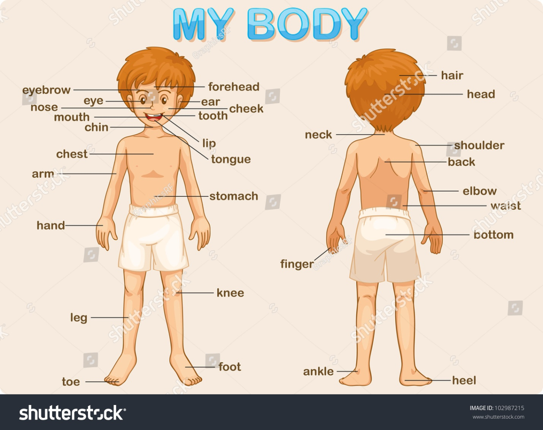
Each part of our body does some work.
Our legs and Feet : Look at these pictures. They show what our legs and feet help us to do .
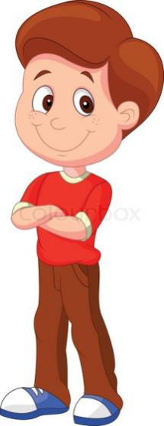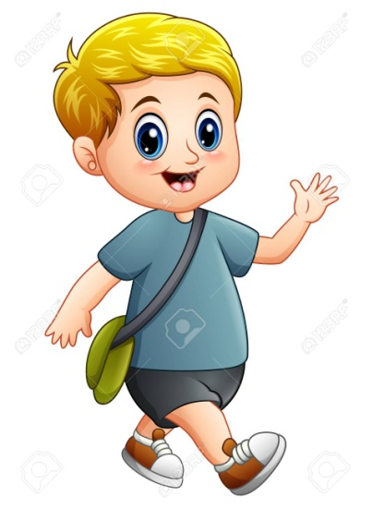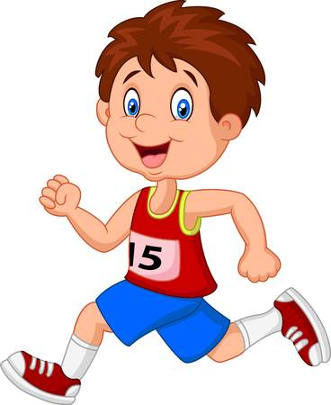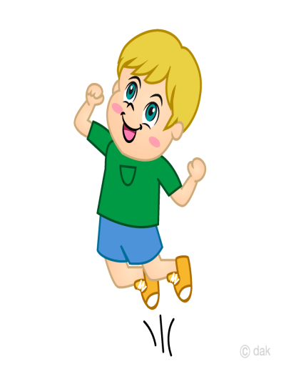
Stand Walk Run Jump
Our hands: Our arms ,hands and fingers help us to –
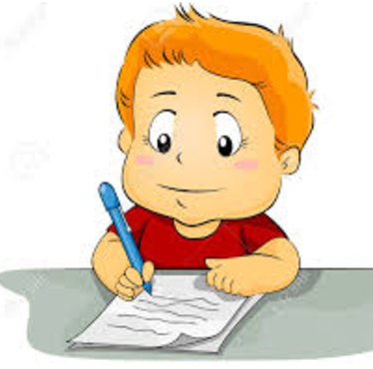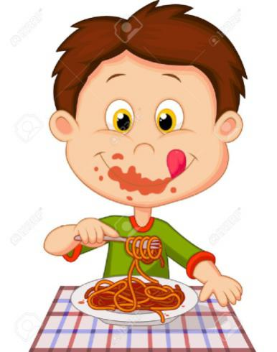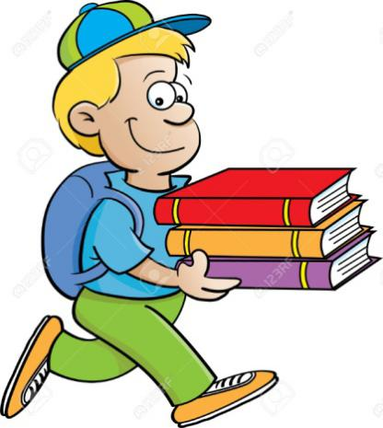
Write Eat Carry
In the same way our hands help us to draw, paint ,throw , hold and to do many other things .We should take care of different parts of our body to keep them in good condition.
Practice work :
- Fill in the blanks with the help of the words given in the brackets.
- We carry our school bag on our __________(head/shoulders).
- Our body is a ____________( wonderful/ electronic) machine.
- Our arms,hands and _________( nose/fingers) help us to eat.
- We should take ________ (care/hurt) of different parts of our body .
- We use our ________(legs/hands) to draw.

- Tick the correct answers.
1)If your hands are tied behind, you will not be able to
(a) run (b)speak (c) hold books

2) Which of these is not a part of our body ?
(a) hand (b) leg (c) pencil

3) Which of these is done with the help of our legs?
(a) kick (b) write (c) throw

- Answer the following questions :
Q1) Which part of your body, do you use to draw ?
__________________________________________________________________________________________________________________________________________________________________
Q2) Which part of your body , do you use to kick the ball ?
____________________________________________________________________________________________________________

