NORTH POINT SENIOR SECONDARY BOARDING SCHOOL
WORKSHEET
CLASS - I

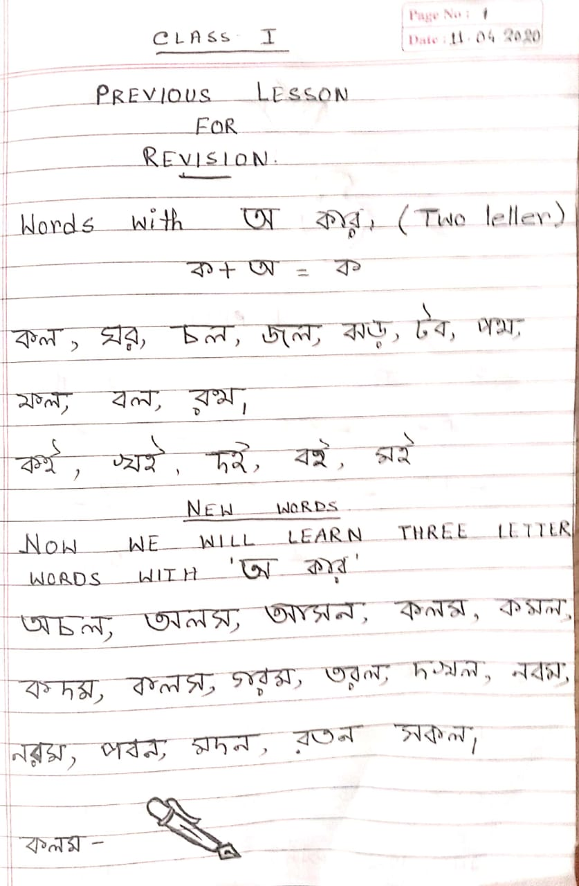
BENGALI

