NORTH POINT SENIOR SECONDARY BOARDING SCHOOL
WORKSHEET
CLASS - I
ENGLISH LANGUAGE

Chapter 1 : The Alphabet

Read these letters | Now,read these letters
A B C D E F G H I J K L M N O P Q R S T U V  W X Y Z | a b c d e f g h i j k l m n o p q r s t u v w x y z
When written like this, they are called capital letters . | when written like this, they are called small letters .

- There are 26 letters in the English alphabet.
- You begin your name and surname with capital letters. The other letters in the name are small letters .
Examples: Kavya Mishra , Ayan Akhtar
- There are five special letters in the alphabet family.
- They are Aa ,Ee , Ii, Oo and Uu. These are called vowels.
- The other letters are called consonants.

Practice work

- Fill in the missing letters.
- A _____ _____ _____ ____ ____ ____ _____ _____ J
- K ____ _____ _____ ____ _____ _____ ____ _____ T
- O ____ _____ _____ _____ _____ _____ _____ ____ X
- M ____ _____ _____ _____ _____ _____ _____ ____ V
- E _____ _____ _____ _____ _____ ____ ____ _____ N
- Fill in the blanks to make a complete set of capital and small letters.

A a B b C c ______ ________ _______ _______ _______

_______ _________ ________ ______ ________ ________

_________ ________ ________ _________ _______ ________

_________ ________ _________ ________ ________ Zz

- Arrange these words in alphabetical order. The first one is being done for you .
- hen cow tiger dog
cow dog hen tiger

- fan cap lamp gum
_________ _________ _________ _________

- hat coat shoes rain
________ __________ ___________ __________

- January February March April
__________ ____________ ____________ ___________

- Fill in a vowel to complete each word. Use capital letters.
1) F___ X
2) B__ Y
3) C___P
4) ___NT
5) D___G
6) ___CE
7) C___T
8) W__LL
9)F___SH
10) N___ST

NORTH POINT SENIOR SECONDARY BOARDING SCHOOL
WORKSHEET
CLASS - I
ENGLISH LITERATURE

Chapter 1 : How Many

Read this poem : I am little Jumbo ,short and fat.
Look at my face and my two bright hats.
I have a nice big smile and a big, big, nose,
And big brown shoes, covering my toes.

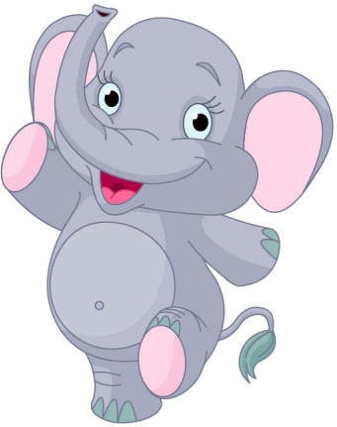

About the story: This is Jumbo. He has two eyes. He has one long nose. He has two big ears. Jumbo loves bananas. He has five bananas. He eats four. Now, he has one. Jumbo sees four apples. He sees one monkey. He sees three birds. He claps his hands. Two birds fly away. Now there is one!

lets learn new spellings
- Jumbo (2) bananas (3)monkey (4)birds (5)clap (6) bright
7)brown (8)toes (9) smile
learning opposites from the lesson
- short- tall (2) fat-thin (3) bright- dull (4) big-small (5) little-much
(6)love-hate
One and many words
 | one | Many
1 | Hat | Hats
2 | Shoe | Shoes
3 | Book | Books
4 | Apple | Apples
5 | Bird | Birds

Practice work:
- Fill in the blanks.
- Jumbo loves _____________.
- Jumbo sees _____________ apples.
- He __________ his hands.
- Two birds _______away.
- Jumbo sees one ____________.

- Write (T) for true and (F) for false statements.
- Jumbo has five bananas _______
- Jumbo has two eyes , two long nose and one big ear ______
- Jumbo loves carrots _____________
- Jumbo sees one monkey ________
- Three birds fly away _______

- Answer the questions.
Q1) Describe Jumbo ?
_________________________________________________________________________________________________________________________________________________________

Q2) Who claps loudly ?
_________________________________________________________________________________________________________________________________________________________

Q3) How many monkeys does Jumbo see ?
_________________________________________________________________________________________________________________________________________________________

Q4)What does Jumbo love ?
_________________________________________________________________________________________________________________________________________________________

