NORTH POINT SENIOR SECONDARY BOARDING SCHOOL
CLASS-I
COMPUTER
NAME: DATE:
- Match the following:
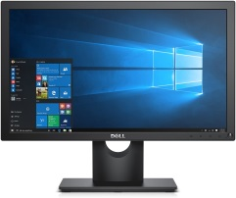 | MOUSE
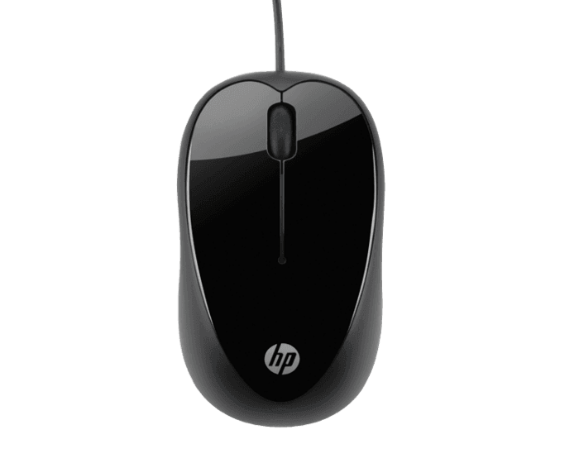 | CPU
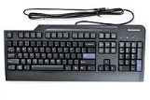 | SPEAKERS
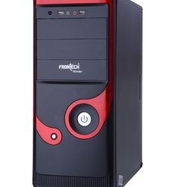 | MONITOR
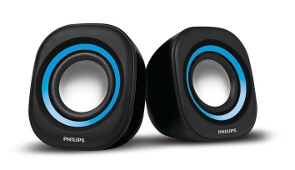 | KEYBOARD
2. Join the dots and Colour:

