NORTH POINT SENIOR SECONDARY BOARDING SCHOOL
CLASS-II
COMPUTER
NAME: DATE:

- 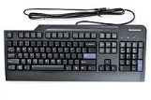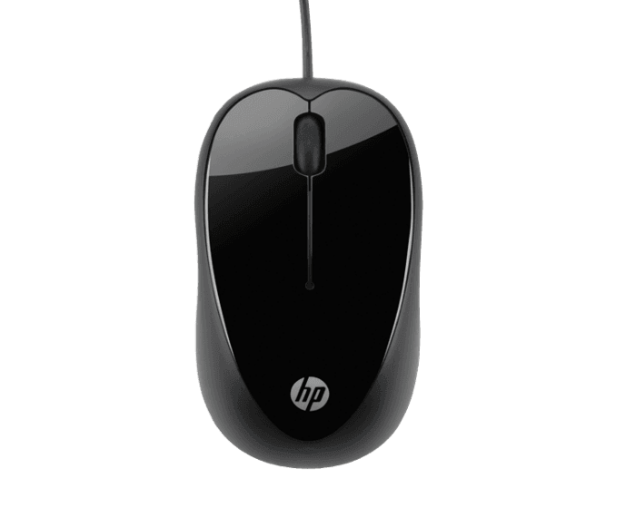Name the Computer Parts:

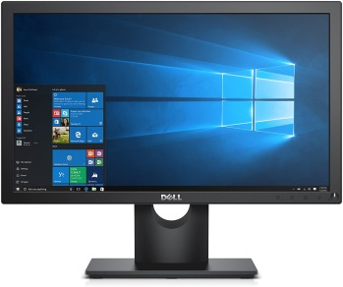

- Fill in the blanks :
        - Mouse has ____________________________ buttons.
        - Mouse is a ____________________________device.
        - Mouse has a __________________________ wheel.
        - Mouse is connected with ______________________.
        - Mouse help us to ___________________________ an object.
3. Draw a Mouse .

