NORTH POINT SENIOR SECONDARY BOARDING SCHOOL
WORKSHEET
CLASS - IV

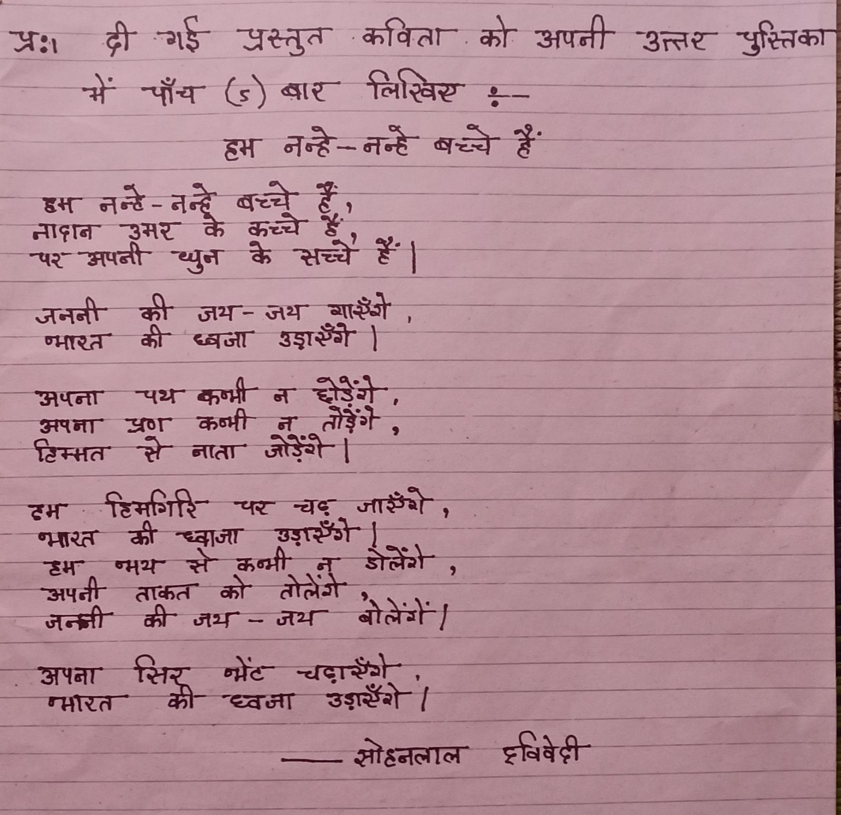
HINDI
