NORTH POINT SENIOR SECONDARY BOARDING SCHOOL
WORKSHEET
CLASS - VII
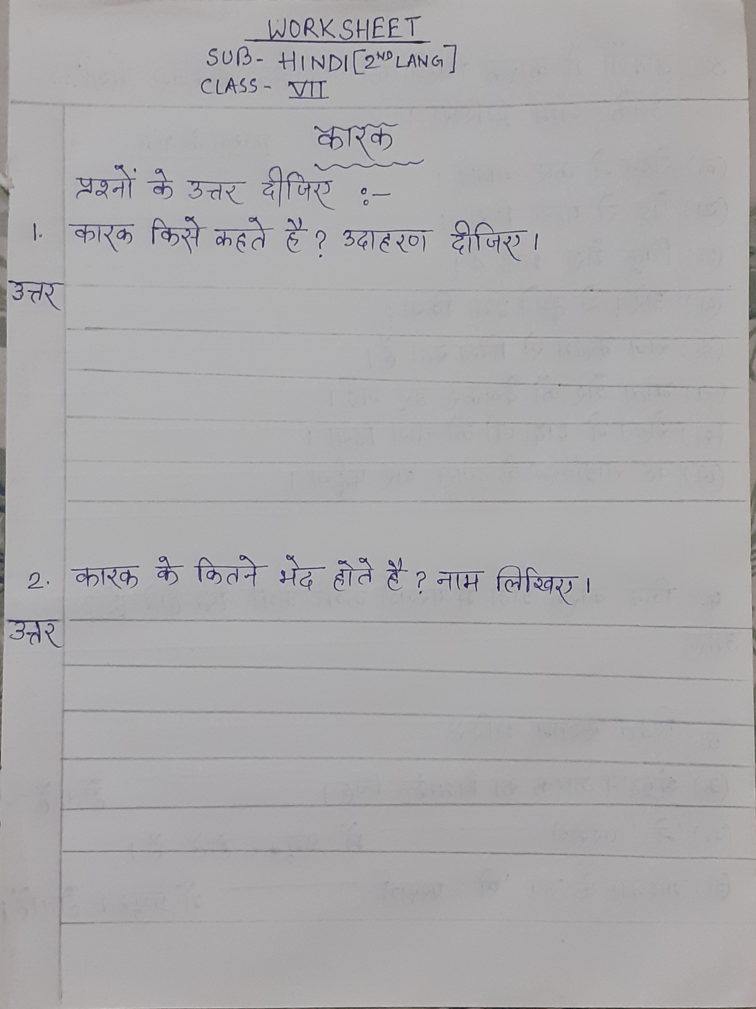
HINDI

