NORTH POINT SENIOR SECONDARY BOARDING SCHOOL
WORKSHEET
CLASS - NURSERY

Phonics : Letter sound to it's picture
Maths : Matching the numbers (revision worksheet)
Alphabets : Revision to be done (S -Z worksheet)

MATHS
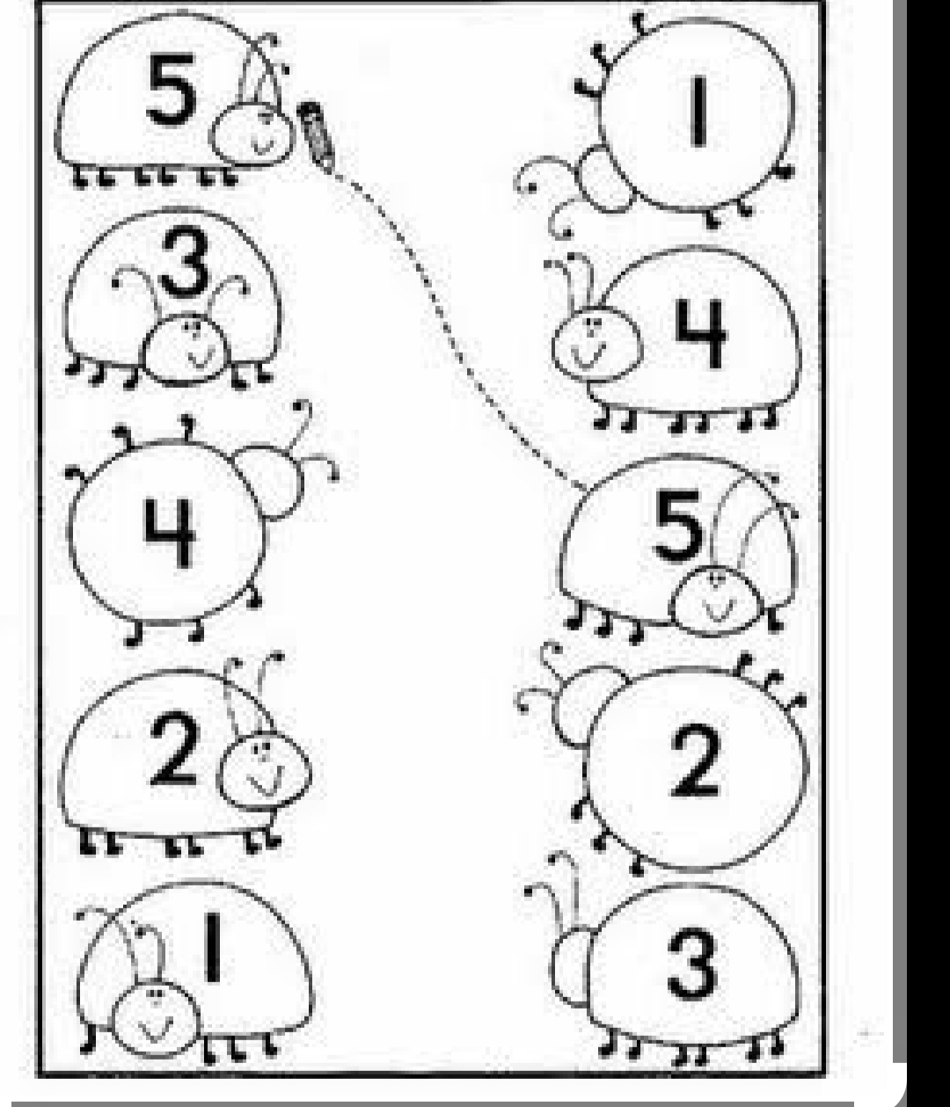

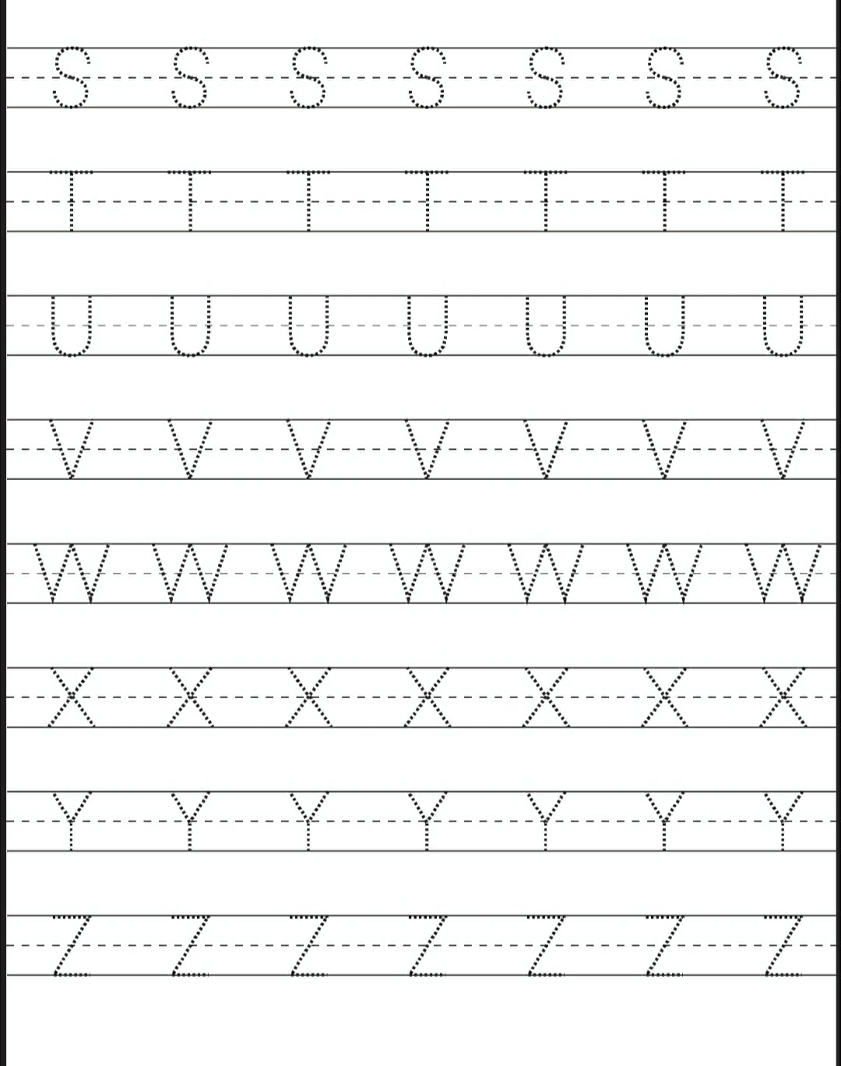
ALPHABETS

