Name _______________

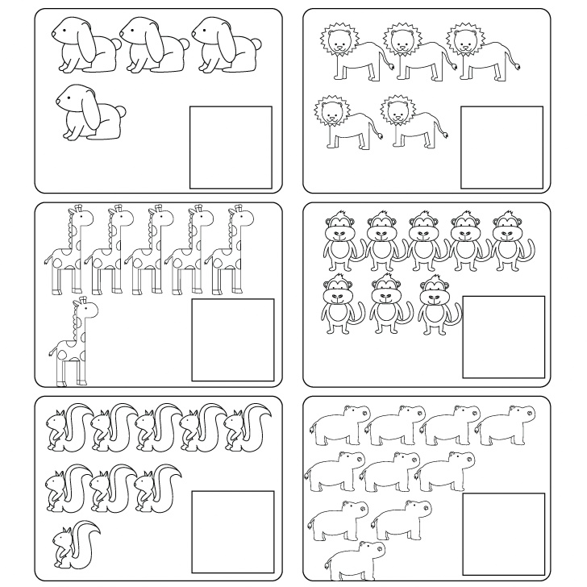
Count the number of animals in each box and write the total number inside the square box.

