Name _______________

A COLOURFUL ICE-CREAM
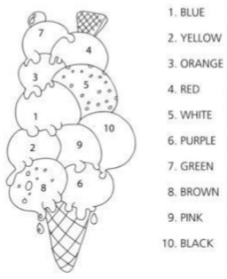
Read and colour.

