Name _______________

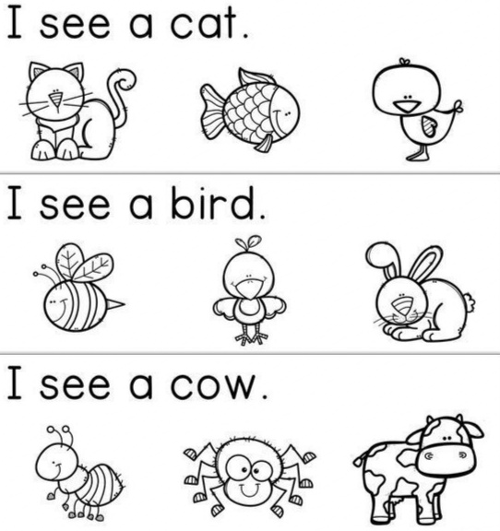
Read the sentence and colour the correct picture.

