Name _______________

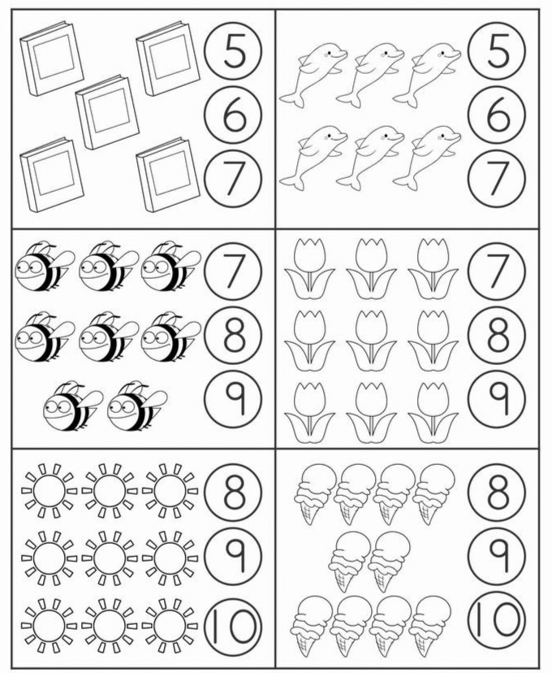
Count and colour the correct number.

