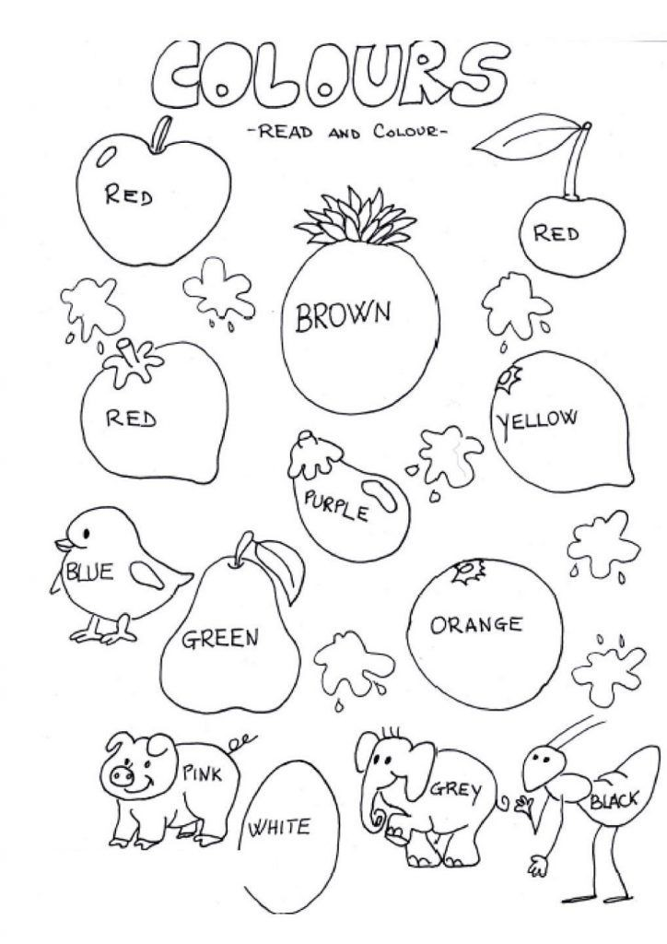Name _______________