NORTH POINT SENIOR SECONDARY BOARDING SCHOOL
WORKSHEET
CLASS - K.G
ENGLISH
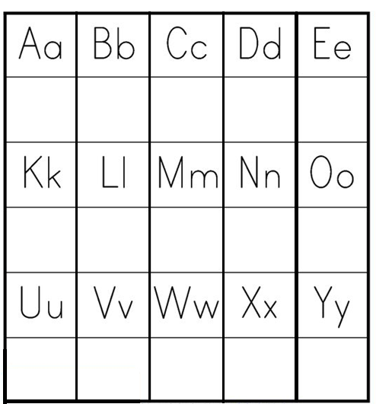
FILL IN THE LETTER ACCORDING TO THE PICTURE

