NORTH POINT SENIOR SECONDARY BOARDING SCHOOL
WORKSHEET
CLASS - KG
MATHS
TOPIC: COMPARISON

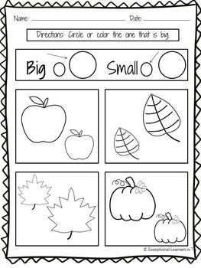
Circle or colour the big object

