^{Math}
^{T.T. Worksheet}
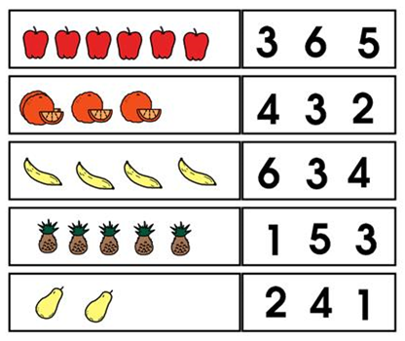
Count the fruits and circle the correct number.

T.T worksheet.

Count and match the objects with the numbers.
