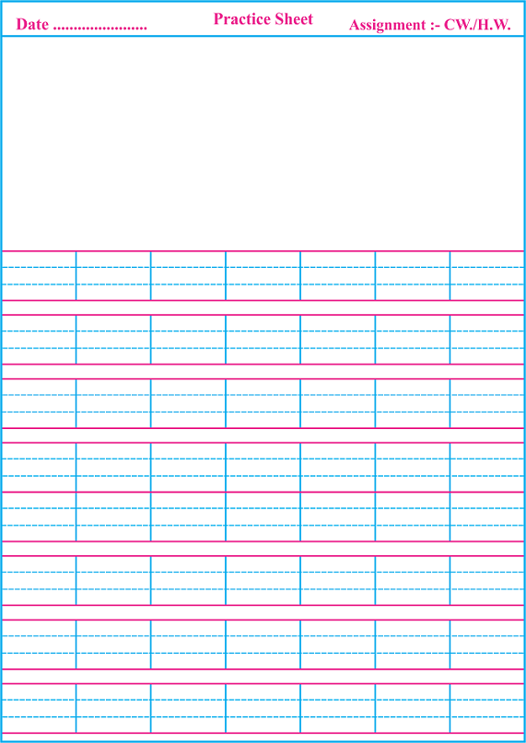T.T.Worksheet English

E

D

C

A

B

Match the letters with the picture



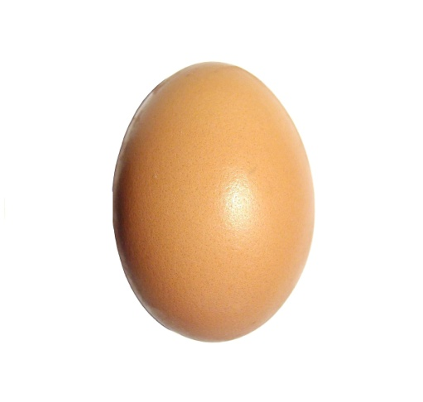 A

 B

C

 D

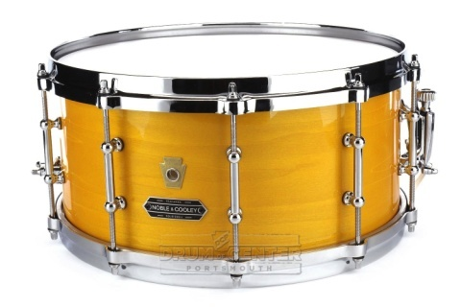 E

T.T. worksheet Maths

Write numbers from 1 to 12

|  |  |  |  |  |  |  |  |  |  |  |
| --- | --- | --- | --- | --- | --- | --- | --- | --- | --- | --- |
| T | O |  | T | O |  | T | O |  | T | O |
|  | 1 |  |  |  |  |  |  |  |  |  |
|  | 2 |  |  |  |  |  |  |  |  |  |
|  | 3 |  |  |  |  |  |  |  |  |  |
|  | 4 |  |  |  |  |  |  |  |  |  |
|  | 5 |  |  |  |  |  |  |  |  |  |
|  | 6 |  |  |  |  |  |  |  |  |  |
|  | 7 |  |  |  |  |  |  |  |  |  |
|  | 8 |  |  |  |  |  |  |  |  |  |
|  | 9 |  |  |  |  |  |  |  |  |  |
| 1 | 0 |  |  |  |  |  |  |  |  |  |
| 1 | 1 |  |  |  |  |  |  |  |  |  |
| 1 | 2 |  |  |  |  |  |  |  |  |  |

Count and match.

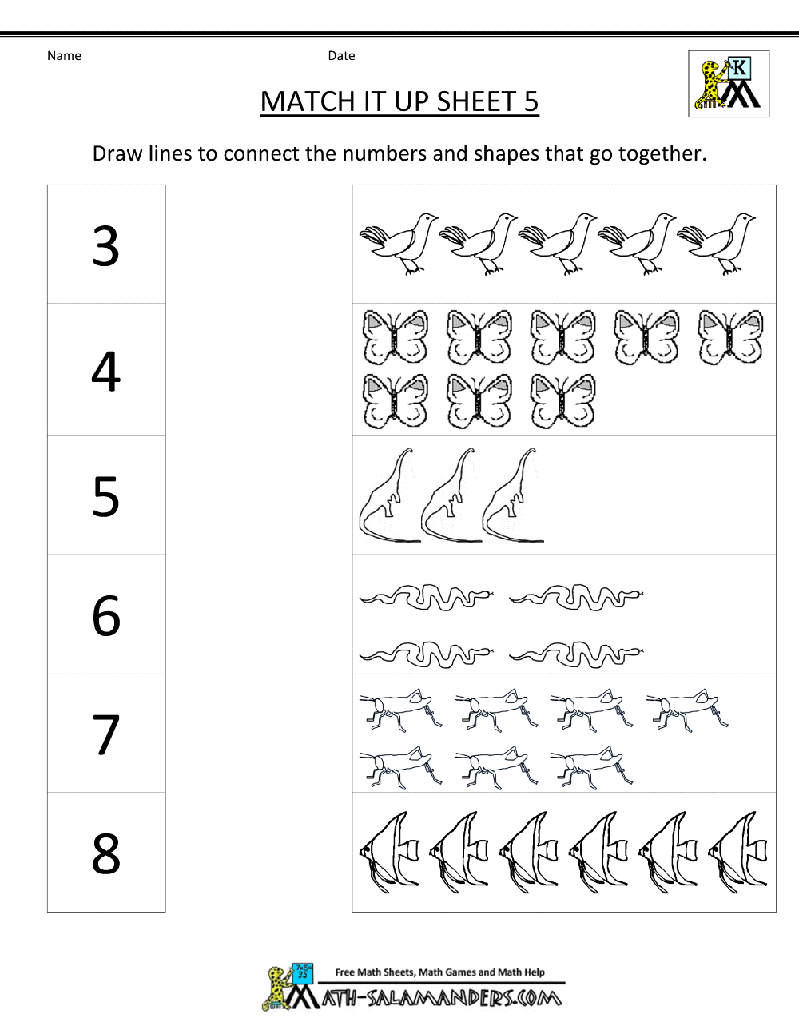

Rhyme Time

