- Class IV
Science worksheet
Give short answers :
1.How many glasses of water should we drink
everyday ?
2.Which organ of our body produces bile?
3.What are the preservatives used in pickles and jams?
4.What does junk food contain?
5.Which organ of our body absorbs extra water ?
6.Why should we eat different types of food?
7.What is an important part of our diet that we cannot digest?
8.Which mineral makes our teeth and bones strong?
9.Which nutrients are called protective foods?
10.Which people need a carbohydrate rich diet?
11.Which part of our body grinds the food?
12.What is the other name of food pipe?
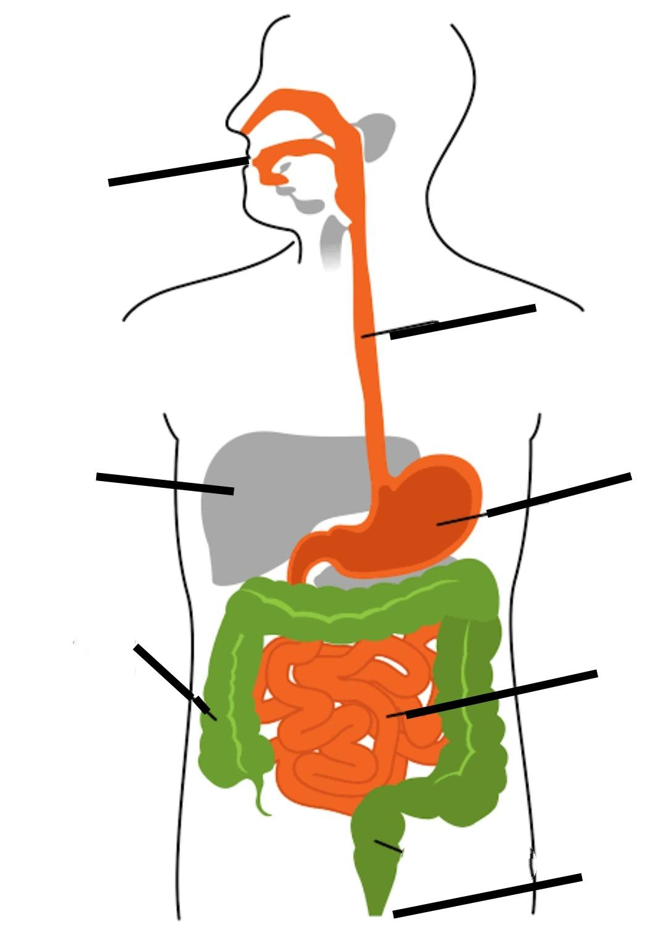
Label the organs of the Human Digestive system

