CLASS VI
SOCIAL SCIENCE WORKSHEET

- HISTORY WORKSHEET

- What do you understand from the image given below?
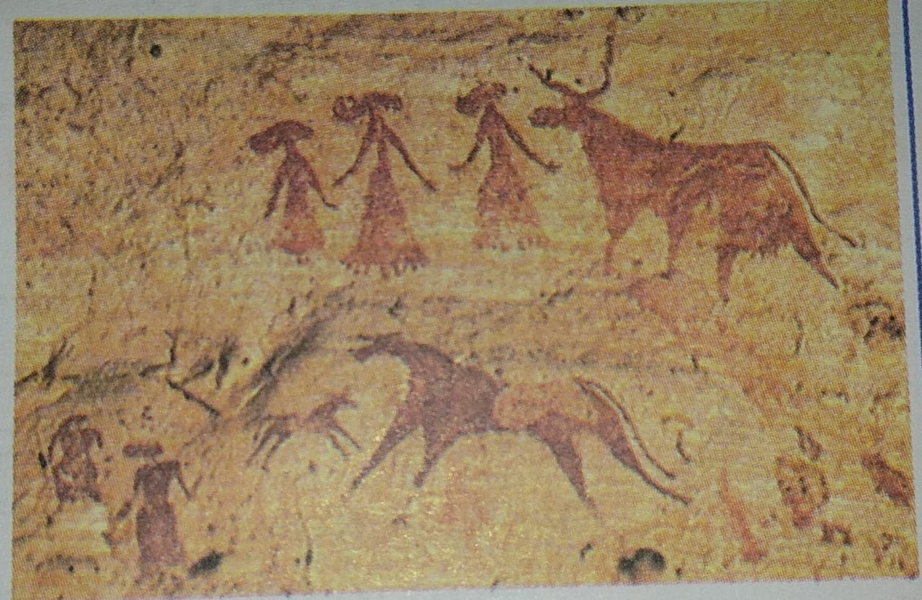
f

- Mention the name of the animals in the given image.
- Name two states in India where these are found.
- What ingredients were used to draw these?

- GEOGRAPHY WORKSHEET

- a. Define rotation
b. What is the time taken by the Earth to complete one rotation?
c. What is the other name of rotation?
d. Write down it’s two effects.
2 a. Define revolution
b. What is the time taken by the Earth to complete one revolution?
c. What is the other name of revolution?
d. Write down it’s two effects.

