IX Solved:
Q 1. What information is shown in Lesson Statistic table?
- Information shown in Lesson Statistic table in touch typing are, we can review our metrics: overall skill level between Beginner and Champion (upper slider indicator) as well as words per minute, characters per minute and accuracy in percent.
In the text area, we can check our mistakes that occurred during the lesson. The color indication is as follows:
- Green letters denote right inputs.
- Yellow letters stand for right inputs exceeding the acceptable timeframe.
- Red letters denote wrong inputs within the acceptable timeframe.
- Orange letters indicate wrong inputs that also exceed the acceptable timeframe (it's the worst result).
Q 2 What is URL? Explain its Components.
URL stands for Uniform Resource Locator. It denotes the address of a website.
Components of URL: Uniform Resource Locators (URLs) are something that we see and deal with all the time. An URL usually consists of the following components:
- Protocol – the method used to process the URL eg. http or https
- Domain – the domain name eg. www.tealium.com
- Path – the section and page on the site
- Hash – identifies a section within the page
- Query String – key/value parameters containing dynamic data passed to the page
Q-3. Write down the steps to insert or delete Rows and Columns.
Insert or delete rows, and columns
Insert or delete a column:
We select any cell within the column & then go to Home --> Insert --> Insert Sheet Columns or Delete Sheet Columns.
Alternatively, we can right-click on the top of the column, and then select Insert or Delete.
Insert or delete a row:
We select any cell within the row & then go to Home --> Insert --> Insert Sheet Rows or Delete Sheet Rows.
Alternatively, we can right-click the row number, and then select Insert or Delete.

Q-4. Differentiate between a bulleted list or numbered list. Explain how to use the symbol as a Bullet.
In a bulleted list each new entry is identified by a "bullet" - often a small circular symbol - to the left of the list entry. In a numbered list this is replaced by a number, in sequential order. Numbered list can be said or defined as the list where numerical comes first before the list point.
To use a symbol as a bullet:
- Select an existing list we want to format.
- On the Home tab, we click on the drop-down arrow next to the Bullets command. ...
- The “Define New Bullet” dialog box will appear. ...
- The Symbol dialog box will appear.
- We click the Font drop-down box and select a font. ...
- We then select the desired symbol, then click OK.

Slide Show view
Q-5. What do you mean by Slide Show view in Power Point?
We can get to SlideShow view from the task bar at the bottom of the slide window.
We use the Slide Show view to deliver our presentation to our audience. Slide Show view occupies the full computer screen, exactly the way our presentation will look on a big screen when our audience views it.

Q-6. Mention some common network security threats. 5.

The most common network security threats

Computer Viruses
Perhaps the most well-known computer security threat, is computer virus which is a program written to alter the way a computer operates, without the permission or knowledge of the user. A virus replicates and executes itself, usually doing damage to our computer.
Carefully evaluating free software downloads from peer-to-peer file sharing sites, and emails from unknown senders are crucial to avoid viruses. Most web browsers today have security settings which can be ramped up for optimum defense against online threats. But, as we'll say again and again in this post, the single most-effective way of fending off viruses is up-to-date antivirus software from a reputable provider.
Learn more about how to combat computer virus threats and stay safe online.

Spyware Threats
A serious computer security threat is the spyware, which is a program that monitors our online activities or installs programs without our consent for profit or to capture personal information. We’ve amassed a wealth of knowledge that will help you combat spyware threats and stay safe online.
While many users won't want to hear it, reading terms and conditions is a good way to build an understanding of how your activity is tracked online. And of course, if a company you don't recognize is advertising for a deal that seems too good to be true, be sure you have an internet security solution in place and click with caution.
We’ve amassed a wealth of knowledge that will help you combat spyware threats- learn more about the dangers of spyware and stay safer online

Hackers and Predators
Hackers and predators are programmers who victimize others for their own gain by breaking into computer systems to steal, change, or destroy information as a form of cyber-terrorism. These online predators can compromise credit card information, lock us out of our data, and can steal our identity.
Q-7. List some important functions of an operating System.
Following are some of important functions of an operating System.
- Memory Management
- Processor Management
- Device Management
- File Management
- Security
- Control over system performance
- Job accounting
- Error detecting aids
- Coordination between other software and users

Q-8 Discuss the components of E-mail in details.

Components of an email with their uses :

Subject. Subject is a description of the topic of the message and displays in most email systems that list email messages individually. A subject line could be something like "2010 company mission statement" or, if your spam filtering application is too lenient, "Lose weight fast!!! Ask me how."

Sender (From). This is the sender's Internet email address. It is usually presumed to be the same as the Reply-to address, unless a different one is provided.

Date and time received (On): The date and time the message was received.

Reply-to. This is the Internet email address that will become the recipient of your reply if you click the Reply button.

Recipient (To:). First/last name of email recipient, as configured by the sender.

Recipient email address. The Internet mail address of the recipient, or where the message was actually sent.

Attachments. Files that are attached to the message.

Body—The text area of the message.

Q-9. Discuss the Characteristics of Primary Memory and Secondary Memory.

Characteristic of Primary Memory
- The computer can't run without primary memory
- It is known as the main memory.
- You can lose data in case power is switched off
- It is also known as volatile memory
- It is a working memory of the computer.
- Primary memory is faster compares to secondary memory.

Characteristic Secondary Memory
- These are magnetic and optical memories
- Secondary memory is known as a backup memory
- It is a non-volatile type of memory
- Data is stored permanently even when the power of the computer is switched off
- It helps store data in a computer
- Slower than primary memory
Q 10. Write down the steps to draw border in excel.
Steps to draw border in excel:
Here's how:
- Click Home-- > the Borders arrow .
- We pick Draw Borders for outer borders or Draw Border Grid for gridlines.
- We Click the Borders arrow --> Line Color arrow, and then pick a color.
- We Click the Borders arrow > Line Style arrow, and then pick a line style.
- Select cells we want to draw borders around.

Q-11. What do you mean by the term Environment? Mention some human activities affecting the Environment.

An ecosystem (also called as environment) is a natural unit consisting of all plants, animals and micro-organisms (biotic factors) in an area functioning together with all of the non-living physical (abiotic) factors of the environment.
Human activity has been affecting the environment for thousands of years, from the time of our very earliest ancestors. Since Homo Sapiens first walked on the earth, we have been modifying the environment around us through agriculture, travel and eventually through urbanization and commercial networks.

1. THE POPULATION BOMB

2. AGRICULTURE, DOMESTICATED ANIMALS AND GENETIC MODIFICATION

3. DEFORESTATION…AND REFORESTATION

4. POLLUTION Both air and water
5. use of plastics
Q12. Differentiate between Intranet and Internet.
Typically, an intranet includes connections through one or more gateway computers to the outside Internet. The internet is the one on which you can access anything and that is what an individual uses at home or on his/her mobile, while Intranet is inter connected network in a company or an organisation.
S.NO | INTERNET | INTRANET
1. | Internet is used to connect different network of computers simultaneously. | Intranet is owned by private firms.
2. | In internet, there are multiple users. | In intranet, there are limited users.
3. | Internet is unsafe. | Intranet is safe.
4. | In internet, There are more number of visitors. | In intranet, There are less number of visitors.
5. | Internet is a public network. | Intranet is a private network.
6. | Anyone can access Internet. | In this, anyone can’t access the Intranet.
7. | Internet provides unlimited information. | Intranet provides limited information.
open the Find pane from the Edit View, press Ctrl+F, or click Home > Find. Find text by typing it in the Search the document for… box. Word Web App starts searching as soon as you start typing.
If you want to find and replace text in a Word document, use the key combo Ctrl + H. That will bring up the “Find and Replace” dialog box.

Q- What are the advantages of Touch Typing Skills? 10 marks
1. Speed. A touch typist can easily reach typing speeds above 75-80 words per minute, while a hunt and peck typist would be hard pressed to reach 30 words per minute. This also increased by the fact that an accomplished touch typist doesn’t have to look at the keyboard. It is difficult to type something while reading it if you have to look down at the keyboard every other stroke to find your next key.
2. Accuracy. One of the most important things to learn no matter how hard you type is to type accurately. Ask anyone who’s ever played a multi player online game, and they’ll tell you how it important it is to be able to type quickly and accurately. No one is going to be able to ride to your rescue if your typing skills are so atrocious that no one can understand what you’re saying.
3. Time. If you increase your typing speed from, say 30 words per minute to 60, you have effectively halved the time it would take you to do the same amount of work. An average two finger typist, typing at for example of 15 words per minute, will type a 250 word section in about 17 minutes. A touch typist, on the other hand, typing at an average 60 words per minute, can type the same section in around 4 minutes.
4. Fatigue. Typing is both mentally and physically exhausting to do for long periods of time. Learning to touch type properly reduces both mental and physical fatigue. Mentally, it keeps you from having to focus on two things at once. All you have to worry about is your output, not finding the individual keys. Physically, it keeps you from constantly having to bend your head over the keyboard to find your next couple of keystrokes.
5. Health. Overall, touch typing is better for your health. You’re not hunched over looking at the keys, and using all of your fingers actually reduces the risk for repetitive stress injuries, or RSI. Many people who work on keyboards or with computers all day are at risk for these repetitive stress injuries.
6. Job Prospects. Typing is not an optional skill anymore. Many employers require computer skills and a certain typing speed to even be considered for some positions. Needless to say, they aren’t looking for 20-30 word per minute hunt and peck typists. Learning to touch type, and to do so accurately, can be one of the most invaluable skills of your career. Want to find out your wpm typing speed, visit a http://www.ratatype.com/typing-test/.
7. Focus. When you’re typing with two fingers, your focus is split between finding the keys on the keyboard and the work you are doing on the computer. Learning to touch type allows you to focus on one thing instead of two. This tends to increase productivity and make it easier to pay attention to the details of your project rather than having to focus on your keys.
8. Editing. If you spend your time staring at your keyboard, you are not going to notice spelling or grammar mistakes until well after you have made them. Touch typing give you the option of editing as you go. You’ll be able to see errors as they appear and backspace to fix them. This is also good for grammar mistakes, as what you see in your head may not sound as good on paper.
Touch typing may seem like it’s not worth the time, especially if you’re already confident in your hunt and peck skills. It is, however, one of the most valuable skills you can learn. It may take a little more time than you would like, especially if you have a life time of bad habits to relearn, but in the end, a small investment of time will pay off in more ways than you can imagine. This is just a basic list of the benefits of touch typing. There are many more out there to discover for anyone who wishes to learn.
Q- Write down the characteristics of Entrepreneurship. 5 marks for any 5 options

1. Self-Motivation
One of the most important traits of entrepreneurs is self-motivation. When we want to succeed, you need to be able to push yourself. You aren’t answerable to anyone else as an entrepreneur, and that sometimes means that it’s hard to get moving without anyone to make you. You need to be dedicated to your plan and keep moving forward — even if you aren’t receiving an immediate paycheck.

2. Understand What You Offer
As an entrepreneur, you need to know what you offer, and how it fits into the market. Whether it’s a product or a service, you need to know where you fit in. That means you need to know when it’s time to tweak things a little bit. This also includes knowing whether you are high end, middle of the road or bargain. Being able to position yourself and then adjust as needed is an important part of entrepreneurship.

3. Take Risks
Successful entrepreneurs know that sometimes it’s important to take risks. Playing it safe almost never leads to success as a business owner. It’s not about taking just any risk, though. Understanding calculated risks that are more likely to pay off is an important part of being an entrepreneur. You’ll need to be willing to take a few risks to succeed.

4. Know How to Network
Knowing how to network is an important part of entrepreneurship. Sometimes who you know is an important part of success. Being able to connect with others and recognize partnership opportunities can take you a long way as a business owner. Figure out where to go for networking opportunities and make it a point to learn how to be effective.

5. Basic Money Management Skills and Knowledge
We often think of successful entrepreneurs as “big picture” people who don’t worry so much about managing the day to day. And it’s true that you might have an accountant or other team members to help you manage the business. However, if you want to be successful, you should still have basic money management skills and knowledge. Understand how money works so that you know where you stand, and so that you run your business on sound principles.

6. Flexibility
To a certain degree, you need to be flexible as an entrepreneur. Be willing to change as needed. Stay on top of your industry and be ready to adopt changes in processes and product as they are needed. Sometimes, you also need flexibility in your thinking. This is an essential part of problem-solving. You want to be able find unique and effective solutions to issues.

7. Passion
Finally, successful entrepreneurs are passionate. They feel deeply about their product or service or mission. Passion is what will help you find motivation when you are discouraged and it will drive your forward. Passion is fuel for successful entrepreneurship. If you find yourself losing your passion, that might be the clue that it’s time to move on to something else (that stokes your passion). There are many serial entrepreneurs that create successful businesses, sell them, and then create something else.
Q- Write down the factors affecting self confidence.

Childhood
Your childhood is one of the main contributing influences to your self-confidence. As you are growing up, your personality and everything else are developing. Everyone around you has the potential to influence the person you become, including your self-confidence and self-esteem.
For example, some children who grow up in a chaotic and unstable environment tend to have lower confidence and self-esteem. However, we have the power to change our mindset and this perception.

Society
The pressure of society is a main contributor of low self-confidence. There are so many demands in our life e.g. to live a particular way, to dress a certain way to get the respect you deserve, to have a certain kind of job and to act accordingly, etc. These pressures are stressing you a lot; failing to resist to the pressure can often lead to low self-esteem.

Media
Most of the women are obsessed with media, whether it is a printing advertisement, television, or social media, contribute to self-confidence issues. Especially, the easy access to social media helps to influence female minds with the pressure to look, act, or otherwise trying to be like celebrities, public figures, or even their peers. It’s hard to compare yourself to other women who are successful, famous and seem to have the perfect life. Women struggle with this situation, but ladies remember that all the advertisements and Social Media posting might not be the real self of these women. You are a woman, you are a unique human being, don’t try to imitate someone else. You won’t be originally you! You will live the the life of someone else.

Spirituality
Some religions and other belief systems can contribute to your self-worth. On the one hand, some religions and belief systems can build your personality and fill your life with love and joy. On the other hand, some religions suggest that people are naturally bad and that you are a “sinner” no matter how you live your life. It depends on your own mindset, what you will believe or not.

Friends and Family
The people you spend time with have a big influence on your self-esteem. Your friends can help you build up your confidence, self-image, and self-respect, or they can bring you down. Some people bring you down on purpose, because they just want to feel better than anyone else.
The family that you grew up with, as well as the family that you created, can have an effect on your self-confidence as well. A family that works together and help each other to grow and evolve can contribute to a healthy self-esteem and strong self-confidence

Relationships
All relationships can influence your confidence, but romantic relationships tend to have the biggest effect. Being in a happy and loving relationship can boost your self-esteem. On the other hand, a bad relationship can bring you down in so many ways. A bad break-up or being left by a partner can also negatively affect your confidence and self-esteem.

Work Environment
You spend so much time at work and you interact with a lot of people with different personality traits. Your work environment would influence or even shape every aspect of your life, including your self-esteem. A stressful and very demanding job can often contribute to a low self-confidence, while a productive and encouraging workplace can help you grow and develop as a person in your personal and professional life.

Health
Your health can also contribute to your self-esteem. Taking care of yourself, body, mind and spirit can strengthen all aspects of yourself including your self-confidence and self-esteem.
Q- Mention the causes of Ecological Imbalances
Ecological Imbalance: Factor # 1.
- Degradation of Land and Soil Erosion:
- Deforestation:
- Faulty Utilisation of Water Resources:
- Environmental Problems from Faulty Mining Practices:
- Industrial and Atmospheric Pollution:
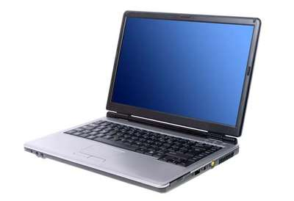

SUMMATIVE ASSESSMENT

INFORMATION TECHNOLOGY
CLASS – IX
The maximum time allowed is 1 hour.
Section A: TOTAL MARKS – 30
Multiple choice Questions: [10 X 1=10]
Functional English
- The Japanese way of saying goodbye _____________ “Sayonara”.
(a) is (b) are (c) being

- She __________________ a passion for reading (has, having)

- ______________ (Any, Few) of us are ready to say “Sorry” but______________ of us always demand it from others. (many, much)

- How much does ________________ automatic camera cost?(A, An , The)

- He refused to ……………. the award.( Accept — Except — Expect)

- I will …………… the table for dinner.( lay — Lie — Laid)

- The……………… of this college is very strict. (Principal — Principle)

- What do you think the line “Negotiation is a tricky art…” mean?
- a) It is difficult b) It is complicated c) It is easy d) None

- Select the correct option:
- a) The Manager was angry at Ravi
- The Manager was surprised
- The Manager disagreed with Ravi
d All are correct
- You can keep my iPod if you like. I ….. it any more.
- don`t use
- doesn`t use
- didn`t use
- am not using

Section B: [7 X 2=14]
Q1. What is a Computer? Write a Note on Computer.

What is a computer?
A computer is an electronic device that manipulates information, or data. It has the ability to store, retrieve, and process data. You may already know that you can use a computer to type documents, send email, play games, and browse the Web. You can also use it to edit or create spreadsheets, presentations, and even videos.
When most people hear the word computer, they think of a personal computer such as a desktop or laptop. However, computers come in many shapes and sizes, and they perform many different functions in our daily lives. When you withdraw cash from an ATM, scan groceries at the store, or use a calculator, you're using a type of computer.

Desktop computers
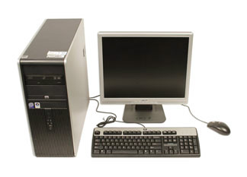
Many people use desktop computers at work, home, and school. Desktop computers are designed to be placed on a desk, and they're typically made up of a few different parts, including the computer case, monitor, keyboard, and mouse.

Laptop computers
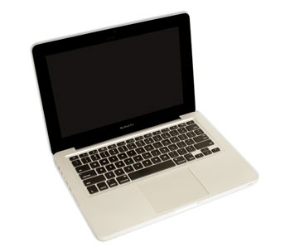
The second type of computer you may be familiar with is a laptop computer, commonly called a laptop. Laptops are battery-powered computers that are more portable than desktops, allowing you to use them almost anywhere.

Tablet computers
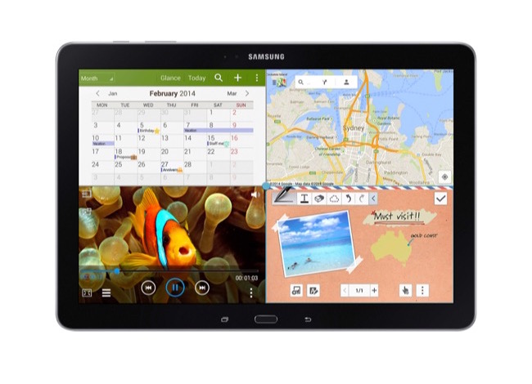
Tablet computers—or tablets—are handheld computers that are even more portable than laptops. Instead of a keyboard and mouse, tablets use a touch-sensitive screenfor typing and navigation. The iPad is an example of a tablet.

Servers
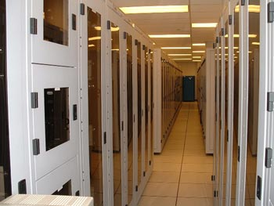
A server is a computer that serves up information to other computers on a network. For example, whenever you use the Internet, you're looking at something that's stored on a server. Many businesses also use local file servers to store and share files internally.

Other types of computers
Many of today's electronics are basically specialized computers, though we don't always think of them that way. Here are a few common examples.
- Smartphones: Many cell phones can do a lot of things computers can do, including browsing the Internet and playing games. They are often called smartphones.
- Wearables: Wearable technology is a general term for a group of devices—including fitness trackers and smartwatches—that are designed to be worn throughout the day. These devices are often called wearables for short.
- Game consoles: A game console is a specialized type of computer that is used for playing video games on your TV.
- TVs: Many TVs now include applications—or apps—that let you access various types of online content. For example, you can stream video from the Internet directly onto your TV.

PCs and Macs
Personal computers come in two main styles: PC and Mac. Both are fully functional, but they have a different look and feel, and many people prefer one or the other.

PCs
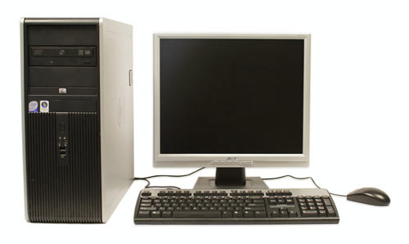
This type of computer began with the original IBM PC that was introduced in 1981. Other companies began creating similar computers, which were called IBM PC Compatible (often shortened to PC). Today, this is the most common type of personal computer, and it typically includes the Microsoft Windows operating system.

Macs
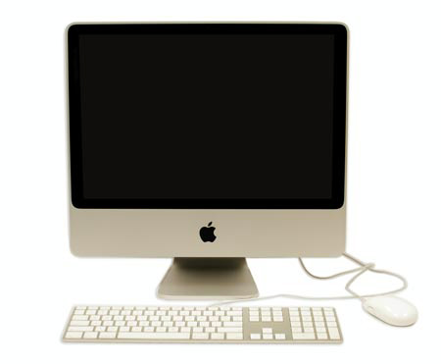
The Macintosh computer was introduced in 1984, and it was the first widely sold personal computer with a graphical user interface, or GUI (pronounced gooey). All Macs are made by one company (Apple), and they almost always use the Mac OS Xoperating system.

Q2. Write 10 Advantages of Computer.

Increase your productivity
Computers increase your productivity and with a good understanding of the software running on them you will become more productive at everything you do. For example, once you have a basic understanding of using a word processor you can create, store, edit, share, and print documents and letters. Each of these things was either impossible or much slower with all pre-existing technologies.

Connects you to the Internet
Connecting a computer to the Internet is what unlocks the power of the computer. Once connected to the Internet your choices and available options are almost limitless, and many of the benefits listed on this page are a computer that is connected to the Internet.
- What things to do when bored on the Internet.
- What are the advantages of the Internet?

Can store vast amounts of information and reduce waste
Computers are capable of storing and accessing vast amounts of information. For example, a computer and devices like eBook readers can store hundreds and if given enough storage could store millions of books. By being able to store books, documents, movies, pictures, and songs digitally, you can quickly find what you need with a searchand share information between devices. It eliminates the need for paper and plastics used to make non-digital versions of the media.

Helps sort, organize, and search through information
A computer can also use its stored information more efficiently than any other device. In our earlier example, we mentioned the ability to store millions of books. Once those books are stored on a computer they can be sorted into categories, alphabetized, and can be searched to find exactly may be looking for in less than a minute. Trying to find the same text in a million books would take a human months if not years.

Get a better understanding of data
Computers can also give you a better understand of data and big data. For example, a business could have a database of items they've sold. Using that data, they can quickly identify what items sell best at what time of year, when to mark up or down an item, and what items are not selling. Having access to this type of information can give the business a better understanding of their customers and a competitive edge against their competitors.

Keeps you connected
Computers can help keep you connect with long distance friends and family over e-mailand social networking. You can also connect with millions of other people that share the same interests as you over online forums, chat, and VoIP services like Skype. Being able to connect to people all around the world is also an excellent way to meet people you would normally never meet.
Another great thing about the communication on the Internet is that it's fast compared to other forms of communication. For example, you could send someone an e-mail on the other side of the planet, and it often arrives in less than a minute or at most a few minutes. Where snail mail (postal mail) would take days or even weeks to arrive.

Can help you learn and keep you informed
The computer and a computer connected to the Internet is a great learning tool and is something that can help answer almost any question and can teach you anything that interests you. You also have access to any news station in the world and can keep up-to-date with all of the latest news, weather, and stories around the world. You could learn a new profession by reading websites or watching videos. You could even sign up for online courses that teach you about any subject you'd learn in school.
- How can I learn more about computers?

Can make you money
When connected to the Internet a computer can help you make money many different ways. For example, it is much cheaper to create and run an online store than having a physical store. Also, once online your store or product has a global audience, and you could potentially sell to anyone in the world.
- How to make money online.
In addition to helping you make money the computer with a spreadsheet is an excellent tool to help keep track of your finances and breakdown your spending habits.

Improves your abilities
Are you not the best speller, have poor grammar, not great at math, don't have a great memory, or need help with something else. By using all of the computers abilities, you can improve all of your abilities or if you have a hard time learning you can rely on the computer to assist you.

Can help automate and monitor
One of the best things a computer can do is be programmed to complete a task and once done be made to repeat that task as many times as you need. For example, a computer could be programmed to move a robotic arm that builds a part for a car or filter, sort, respond, and forward incoming e-mail as it is received.
A computer can automate any imaginable task and can also be programmed to wait for something to occur. For example, computers connected to a camera can be programmed to watch for movement and when detected send an alert and begin recording.

Save time
Today, there are dozens of services that can help save you time. Several examples are listed below.
- Using a site like Amazon, you can find many of the same products you would find at a store for the same price or cheaper. You can also have those items shipped to your door without having to leave your home.
- You could use an online banking site to view your bank balance and pay bills.
- If your favorite restaurant has a website, you can order take out without having to wait in line.
- You can view online traffic cameras and maps with traffic information to find the quickest route.

Assist the physically challenged
Computers are also an excellent tool that can be used to help the physically challenged. For example, Stephen Hawking uses a computer to speak, which wouldn't be as easy without a computer. Computers are also great tools for the blind with special software that can be installed to read what is on the screen. Finally, for those who have a hard time leaving the house, shopping, or socializing a computer can help with all of these tasks.

Find love in your life
Millions of people have found the love of their lives on the Internet through online dating sites. Computers and the Internet make it much easier for people to connect with other people from around the world that are interested in the same things that interest them.

Keep you entertained
With a computer you could store and listen to millions of songs, and watch a DVD and Blu-ray if you have a drive, and when connected to the Internet watch an endless amount of streaming and online video from popular sites like Amazon, Netflix, and YouTube.

Q3. Write 10 Disadvantages of Computer.
Time wastage while doing unproductive activities
Lack of Physical Activity
Causes poor blood circulation
Can result in overeating and obesity
Poor posture causes body-ache
Creates tendency to skip meals
Causes headache
Can lead to insomnia
An unhealthy addiction
Strains the eyes and causes poor eye sight
Has an ill effect on education
Makes you vulnerable to cyber crimes
Tampers your creativity
Results in an Inactive social life
Can cause depression
OR
10. Reduce one’s outlook
A massive use of computers helps to gain knowledge available in the computer frame. But this leads to less participation in real life activities, which makes a man artificial minded. The life of the person is held in a string of world, a string leading between real and unreal.
9. The addictive syndrome
Addiction forwards a man towards resignation from their own thoughts and action. On the first page of history, a man was known as a powerful creature and now he is a slave of an automated machine.
8. Laziness
Sitting several hours in front of a computer implies a man’s laziness. Man’s self respect will be hampered by this laziness. Laziness stops a man’s realization and understanding their intrinsic skills. Proper body functioning is also hampered by laziness.
7. Effect on health
An unhealthy person is always considered to be a step behind from a healthy person. Long time computer usage affects one’s nervous system, which also hampers the proper functioning of the brain. Though the use of a computer is necessary, but the emission of rays from computer leads to various strain disorders. So, effect on health is considered serious among the top ten disadvantages of using computer.
6. Sensitive reason to unproductive activities
A computer is a vast source of information. It also provides games and chat facility for recreation. But spending the whole day in front of computer by availing this recreation facility is nothing constructive. Everyone needs a successful and productive output of individuals.
5. Tampering creativity
The copy – paste method is followed by most of the people to do their assignments, projects and similar tasks. These will definitely hamper the creativity. Computers prevented our extension of thought by providing all required information at ease. God gives some creative capacity to everyone at the time of birth. Proper creativity channelizing makes a man successful in every aspect.

4. Prey to different crimes
This funny automatic machine sometimes forwards a man to some restricted entry places. This also gives the privileges to do spamming, hacking, malware introduction; which are the offenses punishable under the law.
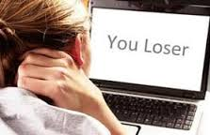
3. Effect on education
Every nation completes its development when their youths join with the seniors. A youth will be developed in all ways when he will get a complete education. The animation for games, chat session form friends attracts them more in the computer rather than study. Thus, they hamper their basic need of becoming a successful man.
2. Strain to the eye
Excessive use of computer creates a strain on human eyes which may cause a permanent damage in the human’s eye. For this reason, the doctors prescribed not to use computers for a long period and thus it is also considered vital among the top ten disadvantages of using computer.
1. Impact on social life
Man is a social animal and their social characters will develop when they interact with each other and share their thoughts or beliefs with each other. Computers can fill a man with knowledge, but it is considered good for nothing, when a proper idea is not placed in the proper situation.

Q4. Write all Five Generations of Computer.

First Generation: Vacuum Tubes (1940-1956)
The first computer systems used vacuum tubes for circuitry and magnetic drums for memory, and were often enormous, taking up entire rooms. These computers were very expensive to operate and in addition to using a great deal of electricity, the first computers generated a lot of heat, which was often the cause of malfunctions.
First generation computers relied on machine language, the lowest-level programming language understood by computers, to perform operations, and they could only solve one problem at a time. It would take operators days or even weeks to set-up a new problem. Input was based on punched cards and paper tape, and output was displayed on printouts. The UNIVAC and ENIAC computers are examples of first-generation computing devices. The UNIVAC was the first commercial computer delivered to a business client, the U.S. Census Bureau in 1951.

Second Generation: Transistors (1956-1963)
The world would see transistors replace vacuum tubes in the second generation of computers. The transistor was invented at Bell Labs in 1947 but did not see widespread use in computers until the late 1950s.
The transistor was far superior to the vacuum tube, allowing computers to become smaller, faster, cheaper, more energy-efficient and more reliable than their first-generation predecessors. Though the transistor still generated a great deal of heat that subjected the computer to damage, it was a vast improvement over the vacuum tube. Second-generation computers still relied on punched cards for input and printouts for output.

From Binary to Assembly
Second-generation computers moved from cryptic binary machine language to symbolic, or assembly, languages, which allowed programmers to specify instructions in words. High-level programming languages were also being developed at this time, such as early versions of COBOL and FORTRAN. These were also the first computers that stored their instructions in their memory, which moved from a magnetic drum to magnetic core technology.
The first computers of this generation were developed for the atomic energy industry.

Third Generation: Integrated Circuits (1964-1971)
The development of the integrated circuit was the hallmark of the third generation of computers. Transistors were miniaturized and placed on silicon chips, called semiconductors, which drastically increased the speed and efficiency of computers.
Instead of punched cards and printouts, users interacted with third generation computers through keyboards and monitors and interfaced with an operating system, which allowed the device to run many different applications at one time with a central program that monitored the memory. Computers for the first time became accessible to a mass audience because they were smaller and cheaper than their predecessors.
Did You Know... ? An integrated circuit (IC) is a small electronic device made out of a semiconductor material. The first integrated circuit was developed in the 1950s by Jack Kilby of Texas Instruments and Robert Noyce of Fairchild Semiconductor.

Fourth Generation: Microprocessors (1971-Present)
The microprocessor brought the fourth generation of computers, as thousands of integrated circuits were built onto a single silicon chip. What in the first generation filled an entire room could now fit in the palm of the hand. The Intel 4004 chip, developed in 1971, located all the components of the computer—from the central processing unitand memory to input/output controls—on a single chip.
In 1981 IBM introduced its first computer for the home user, and in 1984 Apple introduced the Macintosh. Microprocessors also moved out of the realm of desktop computers and into many areas of life as more and more everyday products began to use microprocessors.
As these small computers became more powerful, they could be linked together to form networks, which eventually led to the development of the Internet. Fourth generation computers also saw the development of GUIs, the mouseand handheld devices.
Intel's first microprocessor, the 4004, was conceived by Ted Hoff and Stanley Mazor.

Fifth Generation: Artificial Intelligence (Present and Beyond)
Fifth generation computing devices, based on artificial intelligence, are still in development, though there are some applications, such as voice recognition, that are being used today. The use of parallel processing and superconductors is helping to make artificial intelligence a reality.
Quantum computation and molecular and nanotechnology will radically change the face of computers in years to come. The goal of fifth-generation computing is to develop devices that respond to natural language input and are capable of learning and self-organization.

Q5. Explain: Personal Computer, Notebook Computer and Smart Phone.
A personal computer (PC) may also refer to any small, relatively inexpensive computer designed for an individual user. In price, personal computers range anywhere from a few hundred dollars to thousands of dollars. All are based on the microprocessortechnology that enables manufacturers to put an entire CPU on one chip.

In recent years, the term PC has become more and more difficult to pin down. In general, though, it applies to any personal computer based on an Intel microprocessor, or on an Intel-compatible microprocessor. For nearly every other component, including the operating system, there are several options, all of which fall under the rubric of PC.

PCs at Home
At home, the most popular use for personal computers is for playing games. Businesses use personal computers for word processing, accounting, desktop publishing, and for running spreadsheet and database managementapplications.

Popular PCs of Today
Today, the world of personal computers is basically divided between Apple Macintoshes and PCs. The principal characteristics of personal computers are that they are single-user systems and are based on microprocessors. However, although personal computers are designed as single-user systems, it is common to link them together to form a network. In terms of power, there is great variety. At the high end, the distinction between personal computers and workstations has faded. High-end models of the Macintosh and PC offer the same computing power and graphics capability as low-end workstations.

notebook computer
A notebook computer is a battery- or AC-powered personal computer generally smaller than a briefcase that can easily be transported and conveniently used in temporary spaces such as on airplanes, in libraries, temporary offices, and at meetings. A notebook computer, sometimes called a laptop computer, typically weighs less than 5 pounds and is 3 inches or less in thickness. Among the best-known makers of notebook and laptop computers are IBM, Apple, Compaq, Dell, Toshiba, and Hewlett-Packard.
Notebooks usually come with displays that use thin-screen technology. The thin film transistor or active matrix screen is brighter and views better at different angles than the STN or dual-scan screen. Notebooks use several different approaches for integrating a mouse into the keyboard, including the touch pad, the trackball, and the pointing stick. A serial port also allows a regular mouse to be attached. The PC Card is insertable hardware for adding a modem or network interface card to a notebook. CD-ROM and digital versatile disc drives may be built-in or attachable.
A smartphone is a mobile phone that can do more than other phones.^{[1]} They work as a computer but are mobile devices small enough to fit in a user's hand.
Uses include:
- Sending and receiving emails, text, photographs and multimedia messages
- Registering contacts
- calculator, currency, alarm, etc. functions
- Browsing the Internet using a mobile browser
- Playing games
- Video chat
- point of sale terminal when paying for goods or services
- barcode scanning
- creating high quality photographs or video
- Determining user's exact location utilizing GPS (global positioning system) satellites
Another way to think of them is that they are PDAs that can make voice calls like any other mobile phone. Older phones also used computer technology, but lacked many of the parts of a computer that were too big to fit into a phone. Modern phone makers have been able to use smaller parts. Most smartphones are also GPS receivers and digital cameras.
Because smartphones are small computers, they run an operating system that is often common between devices to ensure compatibility. The majority of smartphones run on Apple iOS or Google Android but others use Windows Phone or BlackBerry OS.^{[2]}Most can do multitasking, running more than one program which helps the user do things quicker and easier. Users can get more programs, called mobile apps, from the manufacturer's app store, such as the Apple App Store and Google Play which can help them complete special tasks.
Data communication has become faster. Smart phones can send and receive data much faster than older phones. The industry uses different standards to label the data transmission rates. 2G was introduced in 1991. 2G means 2nd Generation. 2G phones transmit data at about the same speed as a 56kbit/s (kilobits per second) dial-up modem would get.
3G was introduced in 2002. Depending on where they are, 3G phones vary in speed between about 200kbit/s to 14Mbit/s (megabits per second). This is comparable to a DSL or low end cable modem speed. Most smart phones use 3G technology to make them fast enough to practically use internet and other data features. Faster 4G networks operate in many places, with speeds estimated as fast as 100Mbit/s to 1Gbit/s (gigabit per second). This would be as fast as some computer networks that use ethernet. Many smart phones introduced after 2010 use 4G technology including the later, even faster version of 4G known as LTE. 5G is planned.

Q6. What are the use of Storage Devices, Hard Disk, RAM ,Pen drive and CD ROM?

ADVANTAGES OF HARD DISK DRIVES: HDD VS. SSD
1. More affordable than SSD: One of the primary advantages of a hard disk drive is that it is more affordable than SSD in terms of dollar per gigabit. An SSD with a storage capacity similar with an HDD can be twice as expensive. This means that desktop or laptop computers with hard disk drives are considerably cheaper than counterparts sporting an SSD storage system. External HDDs are also cheaper than external SSDs.
2. Higher storage capacity than SSD: Another advantage of a hard disk drive is that this storage system is available at varying storage capacity options—usually at a higher base capacity than SSD. 500GB HDDs have now become a standard storage capacity for computers and external drives. The availability of more computers and external drives sporting 1TB HDDs is promoting a new standard for storage capacity. On the other hand, compared with an HDD, computers or devices that use an SSD storage system have a base capacity of 128GB.
3. HDD is easier to buy in most stores: There is an abundance of internal or external hard disk drives in the market. Individuals who want to upgrade their computers or want to buy an external media storage to backup their data would find it more convenient to oft an HDD instead of an SSD. However, devices using SSDs are becoming more popular as well and the technology involved in producing this HDD counterpart is becoming more efficient. This could mean that SSDs can have the same availability in the immediate future.
4. Longer lifespan than SSD: Longevity in terms of read-and-write cycle is another worthy advantage of hard disk drives. The flash memories of a solid-state drive can only be used for a finite number of writes. An SSD cannot write a single bit of information without first erasing and then rewriting very large blocks of data at one time. As each cell goes through this cycle, it becomes more useless.

Random access memory (or simply RAM) is the memory or information storage in a computer that is used to store running programs and data for the programs. Data (information) in the RAM can be read and written quickly in any order. Normally, the random access memory is in the form of computer chips. Usually, the contents of RAM are accessible faster than other types of information storage but are lost every time the computer is turned off. Non-volatile random-access memory (NVRAM) keeps its data without using power, but is more expensive and works more slowly, so it is used in smaller amounts.
RAM works using the semi conductive properties of transistors.
RAM is of two types −
Static RAM (SRAM)
Dynamic RAM (DRAM)
Static RAM (SRAM)
The word static indicates that the memory retains its contents as long as power is being supplied. However, data is lost when the power gets down due to volatile nature. SRAM chips use a matrix of 6-transistors and no capacitors. Transistors do not require power to prevent leakage, so SRAM need not be refreshed on a regular basis.
There is extra space in the matrix, hence SRAM uses more chips than DRAM for the same amount of storage space, making the manufacturing costs higher. SRAM is thus used as cache memory and has very fast access.
Characteristic of Static RAM
Long life
No need to refresh
Faster
Used as cache memory
Large size
Expensive
High power consumption
Dynamic RAM (DRAM)
DRAM, unlike SRAM, must be continually refreshed in order to maintain the data. This is done by placing the memory on a refresh circuit that rewrites the data several hundred times per second. DRAM is used for most system memory as it is cheap and small. All DRAMs are made up of memory cells, which are composed of one capacitor and one transistor.
Characteristics of Dynamic RAM
Short data lifetime
Needs to be refreshed continuously
Slower as compared to SRAM
Used as RAM
Smaller in size
Less expensive
Less power consumption
The role of RAM in a computer:
RAM is accessed quickly by the computer's systems and software and stores data and applications along with programs. The graphic user interface, or GUI, is also stored in RAM. Once the computer is turned off, RAM is cleared and only starts up again when the system is computing technology has evolved, RAM has been a key component in the evolution. As operating systems such as Windows or Macintosh OS become increasingly complex, they require more and more space for data storage - or RAM. Computer processors become faster and faster to respond to other technological innovations. The faster the processor, the more demands it makes on RAM.RAM is part of the computer's CPU. Graphic cards may also have their own RAM. The other main type of computer memory is ROM, or read-only memory. ROM does not change and is located in the motherboard; it may also be found in graphic cards or other peripherals. ROM typically contains basic operating instructions for the computer and/or peripherals.
10 smart uses of Pendrive

1. Lock and unlock your computer via Pendrive
People use screen password to protect data stored in computer, laptop. Sometimes it happens that someone ask for personal laptop and ends in accessing your personal information like documents, videos and images, thus provide some sort of password and code that is not known to anyone.
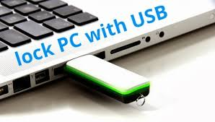
You can also apply a lock on your laptop with the help of Pendrive. Your laptop will not be unlocked until you use the Pendrive. There are various software available to do so like Predator, USB Raptor. If someone attempts to access your system, system will hit the epic message Access Denied.
Must visit : How To Lock & Unlock Your Computer using USB Device As a Key

2. Run Portable apps, utility and games
Pendrive allows you to access applications like Firefox, Thunderbird, Chrome, OpenOffice and other application to be run directly from Pendrive to host computer. OpenOffice is the complete office suite that includes spreadsheet, presentation tools, word processor, database, drawing packages.
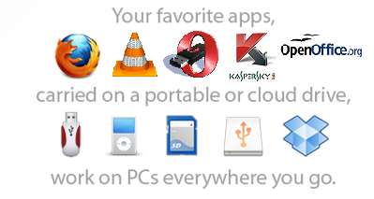
Pendrive helps you to keep everything right in your pocket. You can take any of vital applications with you wherever you are going with Pendrive. Not only this, you can also install the entire pre-packaged suite of applications which includes audio music, games, handy menu system and an antivirus utility.
How To Restore Permanently Deleted Files on PC, USB Drive or SD Cards?

3. Create Rescue Drive
There is no doubt that your pendrive is the ultimate saviour but you must know how to use it in the specific manner to get more from Pendrive. Computers, laptops are more likely to be affected by malware, systems files get corrupted, hard drive dies and many bad things can happen.
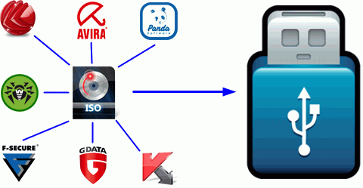
Whatever problem you are facing, you can easily fix it with your Pendrive. Many anti-virus, anti-spyware tools offer to create rescue drivers and CD for saving your computers in case when it not functions properly.
How To Make Your USB Flash Drive Password Protected?

4. Run Dropbox or Google Drive on other PCs
Cloud is becoming more and more popular for storing data on the Internet and to do work in collaboration. If you want to access files, important documents from Google Drive while working on public computer, your Pendrive can help you out. Portable Dropbox or Google Drive must be available in PortableApps suite.
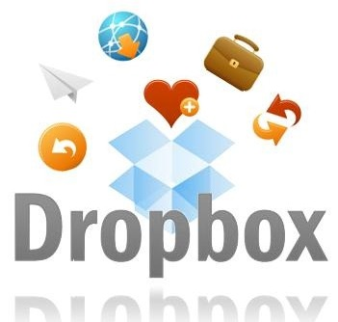

5. Turn your Pendrive in Virtual RAM Drive
If you are Windows Vista or Windows 7 user, you can easily turn your Pendrive into Virtual RAM disks that can help you if you are low on hard space and need some extra space. It is just an alternative as it will not replace real RAM.
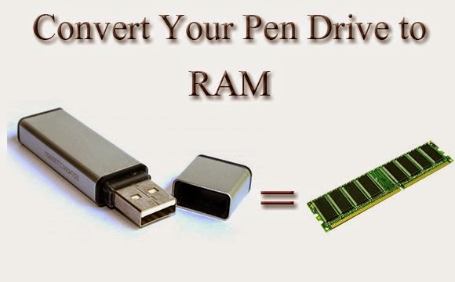

How to encrypt private data inside your USB Flash Drive?

6. Make your data confidential
Whatever you save on your computer can easily be encrypted so that no one gets a chance to steal your personal and confidential data. There are many popular encryption tools including TrueCrypt that offers a way to encrypt an external drive. You can also make use of powerful password managers including KeePass and LastPass to store and use password from it.

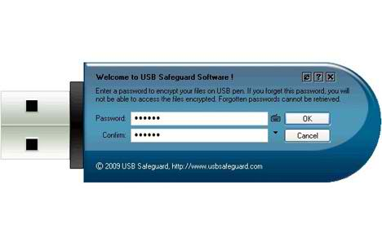7. Use as Bootable device
Booting Operating System using CD or DVD is out of fashion. You can make use of Pendrive to create a bootable version of Operating system whatever you want on your system. You can easily install Windows 7 on your MacBook. You can boot Windows or Linux on your system but you need to be little bit technical to do so.
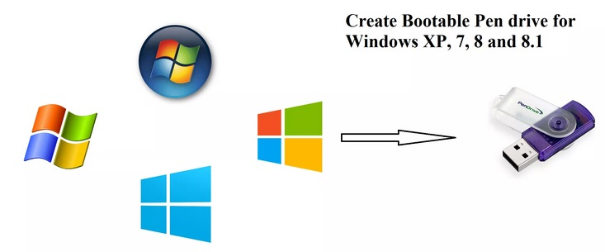

8. Maintain your Windows Computer
You can easily install software that would help you to reset Windows password, clone your system, partition your hard drive and more right from your Pendrive.
Creating Windows 8 Bootable USB Flash Drive For UEFI Boot

9. Connect to Wireless Network
If you are having wireless network, you can save wireless network configuration information to your pendrive. Further you can use your drive to quickly and easily connect another system such as connecting new system to wireless network or connect router or printer. You can learn more through Wireless Network Wizard that you can access from Start menu of Windows XP.

10. Run a website
You can easily run a web server that supports Apache, PHP, Perl and MySQL from your small USB flash drive, Pendrive. Visit Server2Go without any installation. It supports most common browser and run on all versions of Windows.
USES OF CD ROM:
CD-ROM drives are very popular for playing and installing media. CD-ROM drives are classified as 5.25-inch drives because they fit into the 5.25-inch drive bays that are used in computer cases. CD-ROM drives come in many forms, including external, internal, and more.

Data Reading
CD-ROM drives can open documents on data CDs, such as music files, pictures, word documents and other files. However, CD-ROM drives can not write information to a CD (burn) because they are read-only drives; writing information to a CD is done with a CD-R drive.

Music Playback
CDs can be created in two forms, an audio CD and a data CD. Data CDs can only be opened by computers and other CD players. However, audio CDs can be played by any CD player, such as in most newer car stereos or a portable CD player.

Software Installation
CDs are widely used as installation discs. Whenever there is software included with a product that you buy in a store, or just the software itself, it is highly likely that it is stored on a CD. Before software could be downloaded off the Internet, it was exclusively distributed in CDs and floppy diskettes.
Q7. Write a Note on Windows Operating System.
Windows OS, computer operating system (OS) developed by Microsoft Corporation to run personal computers (PCs). Featuring the first graphical user interface (GUI) for IBM-compatible PCs, the Windows OS soon dominated the PC market. Approximately 90 percent of PCs run some version of Windows.

READ MORE ON THIS TOPIC
computer: Microsoft’s Windows operating system
In 1985 Microsoft came out with its Windows operating system, which gave PC compatibles some of the same capabilities as the Macintosh. Year after year, Microsoft refined and improved Windows so that Apple, which failed to come up with a significant new…

The first version of Windows, released in 1985, was simply a GUI offered as an extension of Microsoft’s existing disk operating system, or MS-DOS. Based in part on licensed concepts that Apple Inc. had used for its Macintosh System Software, Windows for the first time allowed DOS users to visually navigate a virtual desktop, opening graphical “windows” displaying the contents of electronic folders and files with the click of a mouse button, rather than typing commands and directory paths at a text prompt.
Subsequent versions introduced greater functionality, including native Windows File Manager, Program Manager, and Print Manager programs, and a more dynamic interface. Microsoft also developed specialized Windows packages, including the networkable Windows for Workgroups and the high-powered Windows NT, aimed at businesses. The 1995 consumer release Windows 95 fully integrated Windows and DOS and offered built-in Internet support, including the World Wide Webbrowser Internet Explorer.
With the 2001 release of Windows XP, Microsoft united its various Windows packages under a single banner, offering multiple editions for consumers, businesses, multimedia developers, and others. Windows XP abandoned the long-used Windows 95 kernel (core software code) for a more powerful code base and offered a more practical interface and improved application and memory management. The highly successful XP standard was succeeded in late 2006 by Windows Vista, which experienced a troubled rollout and met with considerable marketplace resistance, quickly acquiring a reputation for being a large, slow, and resource-consuming system. Responding to Vista’s disappointing adoption rate, Microsoft in 2009 released Windows 7, an OS whose interface was similar to that of Vista but was met with enthusiasm for its noticeable speed improvement and its modest system requirements.
Windows 8 in 2012 offered a start screen with applications appearing as tiles on a grid and the ability to synchronize settings so users could log on to another Windows 8 machine and use their preferred settings. In 2015 Microsoft released Windows 10, which came with Cortana, a digital personal assistant like Apple’s Siri, and the Web browser Microsoft Edge, which replaced Internet Explorer. Microsoft also announced that Windows 10 would be the last version of Windows, meaning that users would receive regular updates to the OS but that no more large-scale revisions would be done.

Section C: [3 X 2=6]

Q1. Differentiate between a Typewriter and Computer.
Q2. Write any 10 Advantages of Good Typing.

Difference between typewriter and computer - wiki answers

- A computer on its own cannot print: it requires an external device to print
- A computer printer is useless without a computer to drive it, but a typewriter is self-contained
- While modern typewriters are electric, the majority of typewriters for decades were manual - no electricity required. A computer cannot function with electricity of some description (including batteries)
- A typewriter creates the letters by pressing ink through a ribbon
- The computer is well known, whereas a typewriter has never been seen by some of the younger generation
- Some forms of modern typewriter can "erase" mistakes: no printer has this function because it can all be controlled through the computer

Write 5 advantages of good typing.
A Well, here’s 5 ways touch typing can benefit you:

Typing Speed
Touch typing can drastically improve your typing speed. Maybe you have been using the hunt and peck method all of your life or some variation of placing all 10 fingers on the keyboard. Either way, these methods are incredibly slow compared to touch typing. Using a program like TypingMaster Online can help improve your typing speed dramatically in a short period of time. Not only does this skill make you more attractive to employers, but it will help you become more efficient and can save you time as well.

Time
Think about this: if you are currently typing 20 words per minute (wpm) that means it would take you on average about 30 minutes to type up a one page document. Factor in time to think about what you want to say and the time it takes to start and stop if you need to look at the keyboard and you could be looking at close to an hour to get that task done.
By learning touch typing, you could boost your typing speed to 40wpm or even 60wpm and drastically cut down the amount of time it takes you to do even the most simple tasks. Not only will you become more efficient, but you will also be able to direct your focus to where it counts.
Curious to see what your typing speed is? Take our free typing test now

Focus
Think about every time you have to look at the keyboard to find the right key. Or, maybe you find yourself constantly making mistakes and having to go back and make corrections as you type.
Each time this happens, it breaks your focus and become distracted. Touch typing can teaches you to rely on motor memory rather than sight to type, freeing you up to direct your focus on the screen instead of the keyboard.

Health
If you spend a significant amount of time at a desk, in front of a computer then you probably know that sitting and typing can take a toll on your body. Achy shoulders, stiff neck and sore wrists are some of the side effects of poor posture and bad computer habits.
As you learn the proper way to sit and cultivate better habits, your arms and shoulders will relax and your energy levels will stay consistent throughout the day. Touch typing isn’t just about increasing your typing speed and reducing errors, it’s about adopting healthy computer habits to reduce the risk of injury and provide increased comfort.

Touch typing improves productivity
By learning the basics of touch typing, you will find your work and personal life to become much more productive. Type emails, reports and chat at the speed of your speech and see the results as you get more done during your day.
Whether you are an educator, employee or student, TypingMaster Online an help you save time, become more productive and make typing more enjoyable. Experience for yourself the benefits of touch typing, take TypingMaster typing test now and find out your typing speed.

Advantages of Touch Typing Skills
1. Speed. This is going to be the first and most obvious benefit of learning to touch type. A touch typist can easily reach typing speeds above 75-80 words per minute, while a hunt and peck typist would be hard pressed to reach 30 words per minute. This also increased by the fact that an accomplished touch typist doesn’t have to look at the keyboard. It is difficult to type something while reading it if you have to look down at the keyboard every other stroke to find your next key.
2. Accuracy. One of the most important things to learn no matter how hard you type is to type accurately. Ask anyone who’s ever played a multi player online game, and they’ll tell you how it important it is to be able to type quickly and accurately. No one is going to be able to ride to your rescue if your typing skills are so atrocious that no one can understand what you’re saying.
3. Time. If you increase your typing speed from, say 30 words per minute to 60, you have effectively halved the time it would take you to do the same amount of work. An average two finger typist, typing at for example of 15 words per minute, will type a 250 word section in about 17 minutes. A touch typist, on the other hand, typing at an average 60 words per minute, can type the same section in around 4 minutes.
4. Fatigue. Typing is both mentally and physically exhausting to do for long periods of time. Learning to touch type properly reduces both mental and physical fatigue. Mentally, it keeps you from having to focus on two things at once. All you have to worry about is your output, not finding the individual keys. Physically, it keeps you from constantly having to bend your head over the keyboard to find your next couple of keystrokes.
5. Health. Overall, touch typing is better for your health. You’re not hunched over looking at the keys, and using all of your fingers actually reduces the risk for repetitive stress injuries, or RSI. Many people who work on keyboards or with computers all day are at risk for these repetitive stress injuries.
6. Job Prospects. Typing is not an optional skill anymore. Many employers require computer skills and a certain typing speed to even be considered for some positions. Needless to say, they aren’t looking for 20-30 word per minute hunt and peck typists. Learning to touch type, and to do so accurately, can be one of the most invaluable skills of your career. Want to find out your wpm typing speed, visit a http://www.ratatype.com/typing-test/.
7. Focus. When you’re typing with two fingers, your focus is split between finding the keys on the keyboard and the work you are doing on the computer. Learning to touch type allows you to focus on one thing instead of two. This tends to increase productivity and make it easier to pay attention to the details of your project rather than having to focus on your keys.
8. Editing. If you spend your time staring at your keyboard, you are not going to notice spelling or grammar mistakes until well after you have made them. Touch typing give you the option of editing as you go. You’ll be able to see errors as they appear and backspace to fix them. This is also good for grammar mistakes, as what you see in your head may not sound as good on paper.
Touch typing may seem like it’s not worth the time, especially if you’re already confident in your hunt and peck skills. It is, however, one of the most valuable skills you can learn. It may take a little more time than you would like, especially if you have a life time of bad habits to relearn, but in the end, a small investment of time will pay off in more ways than you can imagine. This is just a basic list of the benefits of touch typing. There are many more out there to discover for anyone who wishes to learn.

