^{English}
^{What are we learning today ?}
Introduction to letter “E” and “F”.
Recapitulation of letter A to F.
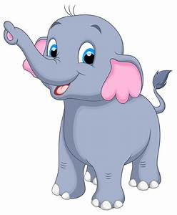
^{Introduction with “E” story.}

^{Eli The Elephant}

Eli the elephant lived in the jungle. His best friend was Elu the emu. Both the friend loved his to eat egg plant.One day it was Eli’s birthday .All his friends were invited for the party.Only Eva the eagle could not attend the party because was not well . He had sent Eli ,a birthday card in an envelope through the eal.All the friends enjoyed birthday party but they missed Eva the eagle.
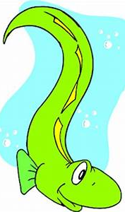
emu
Egg plant
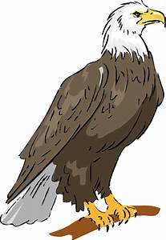
eel
eagle
envelope

Circle the pictures that start with letter E.

Introduction of letter “F”.
Words with letter “F” .
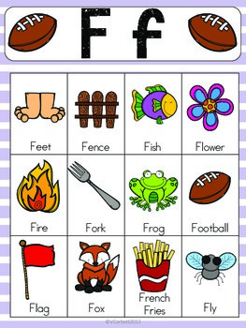

Colour the picture with letter “F”

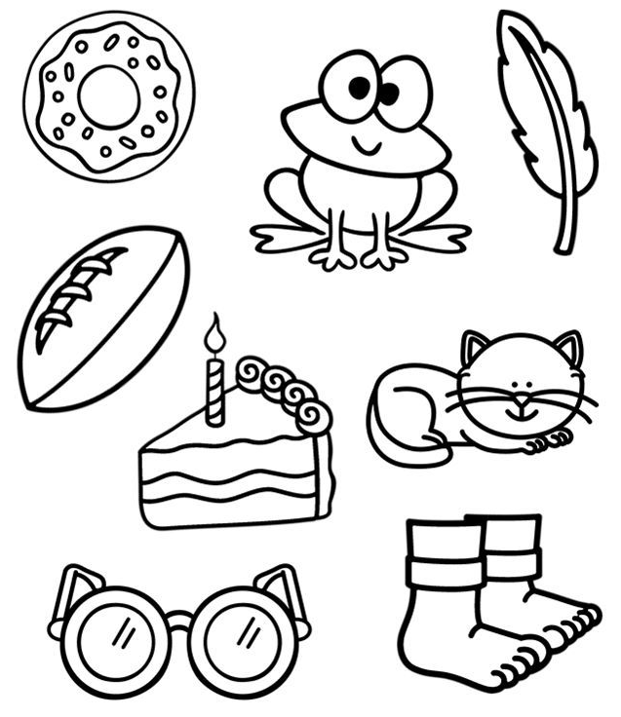

Match the letter with the pictures.

