CLASS III
EVS WORKSHEET
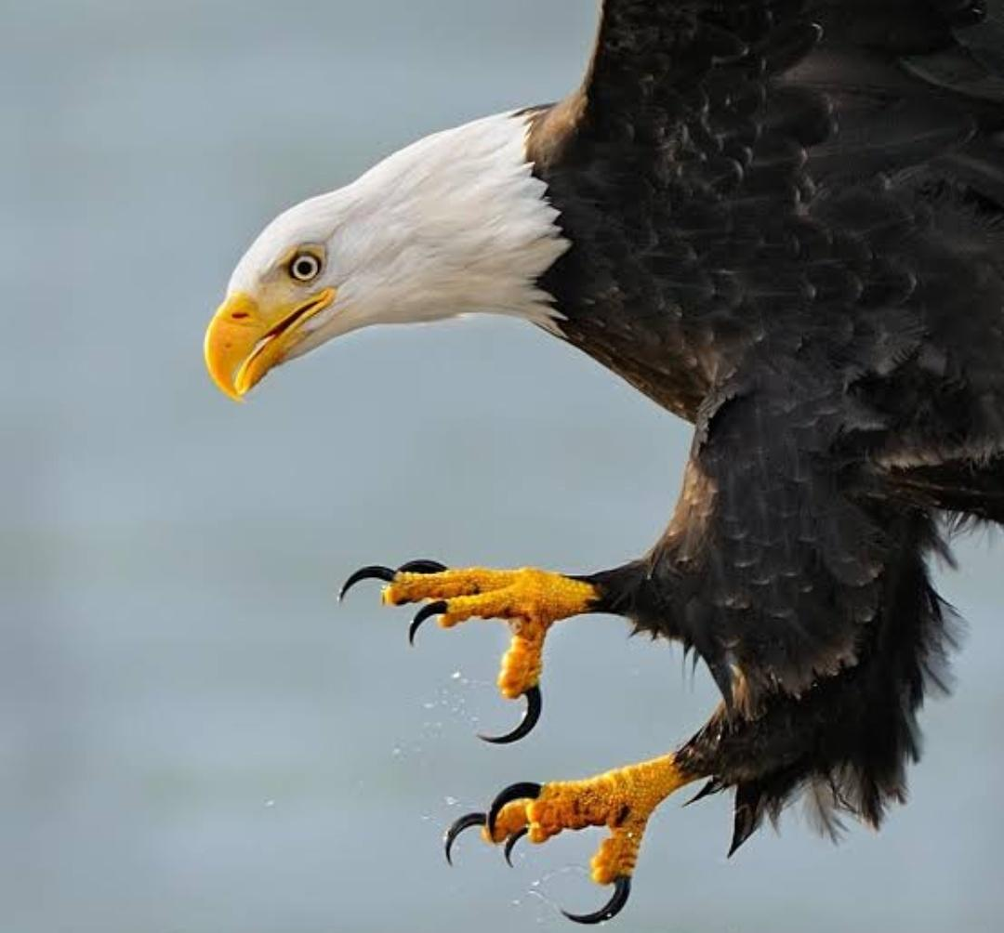
1.Identify the following bird.

2.Why does this bird have a strong, sharp hooked beak?
__________________________________
3.What are it’s claws also known as?
_____________________________

4. What do they eat ?
_________________

5.Name two birds of prey.

6.Draw and describe their nest.

