CLASS VI
GEOGRAPHY WORKSHEET
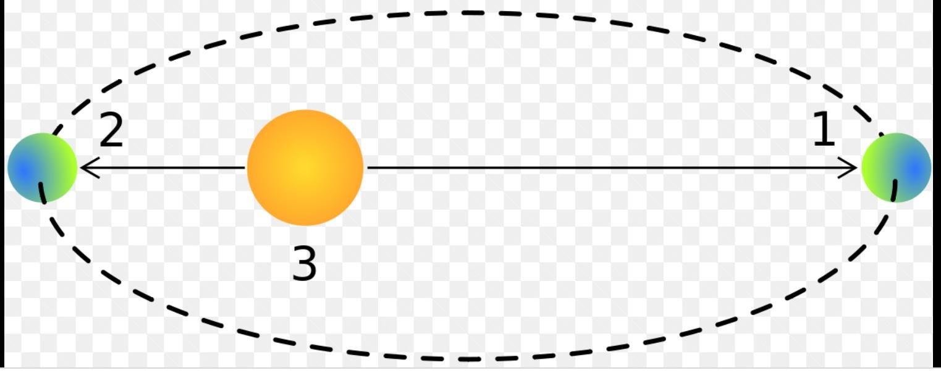
1.Is the distance between the Sun and the Earth same throughout the year?

2.Identify the Perihelion and Aphelion
Position of the Earth from the above diagram.
3.What is the average distance between the Sun and the Earth?

4.What is the distance between the Sun And the Earth during ‘Perihelion ‘?

5.What is the meaning of ‘Aphelion’?

6.Mention the dates of ‘Perihelion' and ‘ Aphelion ‘.

7.What is the maximum distance between the Sun and the Earth?

8.What is the shape of the Earth’s orbit?

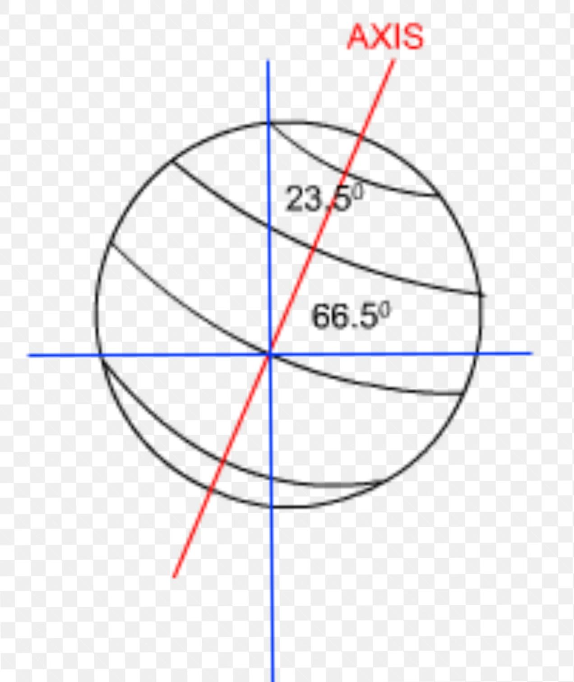
A .Fill in the blanks :

1.The Earth's axis is tilted to one side while moving, this tilt is called _______
Of the Earth's axis.
2.The axis is inclined from the ______
Line at an angle of 23 ½° (23•5 °) .

3.The axis makes an angle of 66 ½°
(66•5 °)With its ___________ plane.

B. Give the answer of the following questions.
1.Name two solstices.

2.Name two Equinoxes.

3 List two reasons for the cycle of seasons.

4.Name five seasons on the Earth.

