CLASS VI
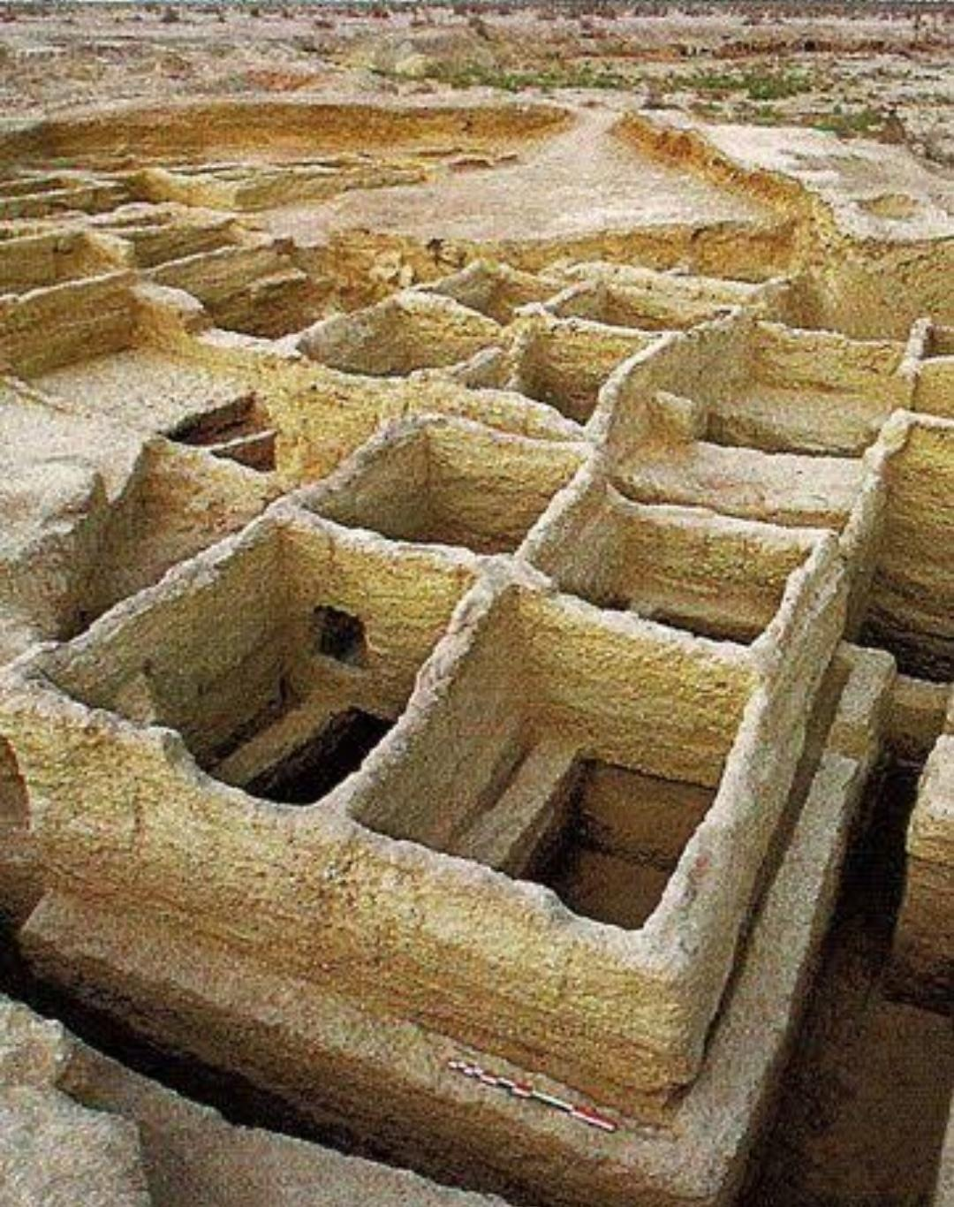
HISTORY WORKSHEET
- Identify the above image.

- Mention the place , at present.

- Mention the name of an animal found in this area from the earliest level.

- Mention the occupation of the people during Neolithic age.

- Describe the houses of this area.

