CLASS VII
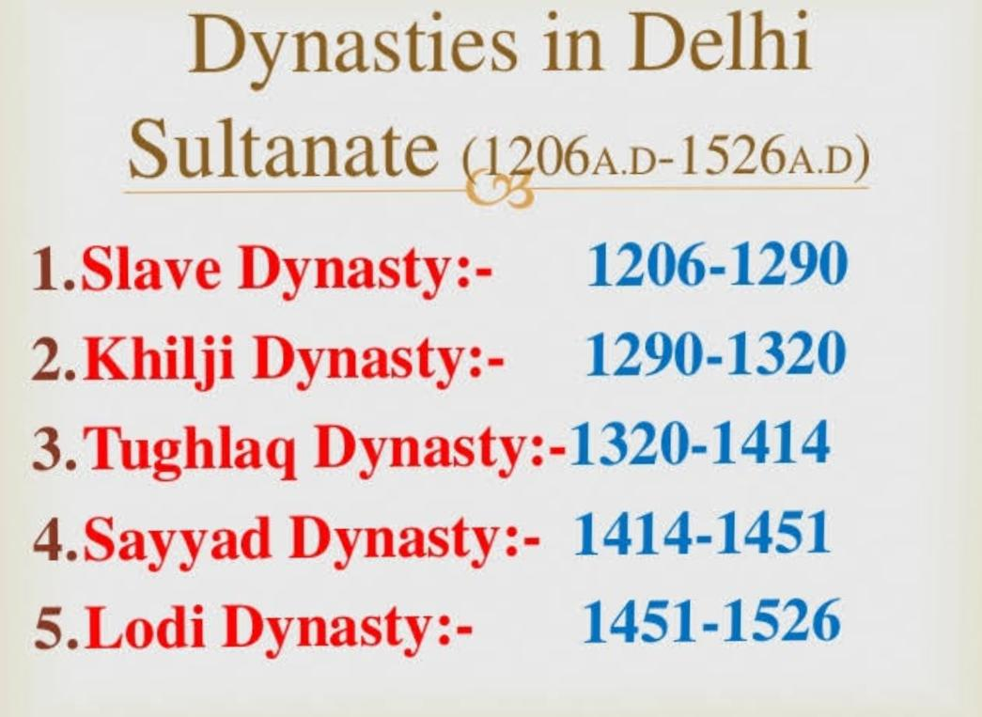
HISTORY WORKSHEET

FILL IN THE BLANKS :
1.The Delhi Sultanate set the stage for an interesting phase in history called the Later __________ period.

2. Inscriptions, _______ and monuments
Provide a lot of information about this period.

3.Historical records written in Persian are called ___________

4.The rulers of Slave dynasty were called
Slaves or __________ Sultans.

5.______________________ was the founder
Of Slave Dynasty.

6.The founder of slave dynasty was honoured with a title of ____________.

7.______________ was the actual founder of Delhi Sultanate in the reign of Slave dynasty.

8._______________ rode on elephants like males, hunted and led the army was a progressive thinker and a dynamic ruler of Slave dynasty.
9._____________ was the most powerful ruler of the Slave dynasty .He also successfully guarded the North western borders against Mongol raids.

10.__________and ____________ ,the two Persian customs according to common people were reserved for God.

