CLASS VI
MAP POINTING

- ASIA (PHYSICAL MAP)
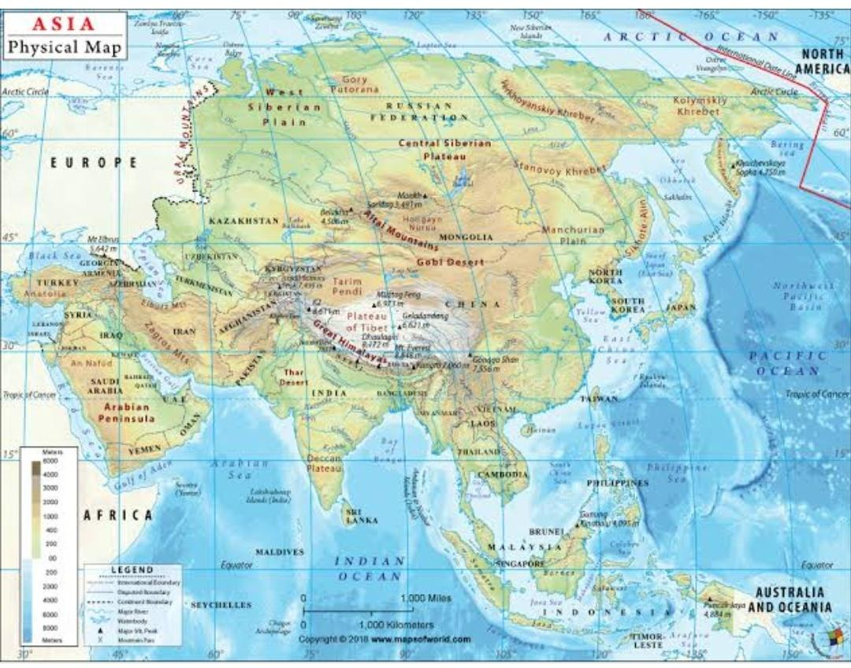
Mark the following
1.Bering strait, 2.Indian ocean, 3.Tibet

- AFRICA (PHYSICAL MAP)
Mark the following
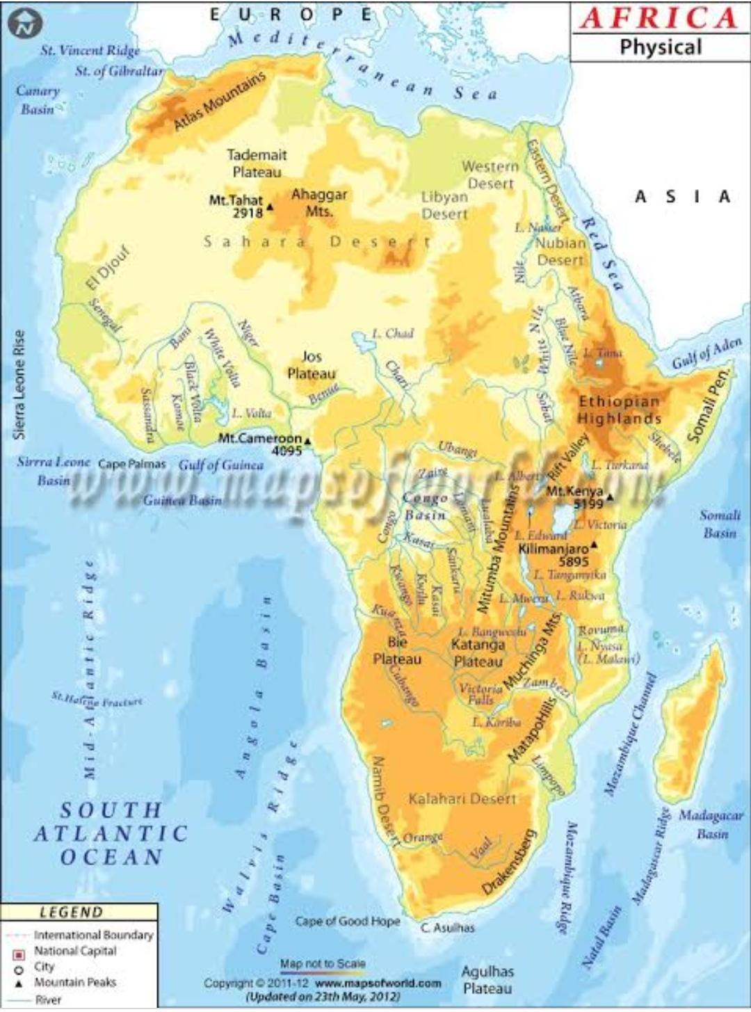
1.Congo basin 2.Sahara desert 3.Atlantic Ocean

