Getting to Know Plants

Q1. True / False
a. All plants are of same size. False
b. Photosynthesis takes place in the absence of light. False
c. Transpiration and Photosynthesis are the main function of leaf. True
d. Roots hold the plant above the soil. False
e. Pistil is the female part of the flower. True

Q2. Fill in the blanks.
a. Major parts of plants are the stem, branches, roots, leaves and flowers.
b. Plants can be classified into three categories: herbs, shrubs and trees.
c. Photosynthesis is the process by which leaves prepare food for the plant.
d. Two types of roots are tap root and fibrous root.
e. Stamen is the male part of the flower.

Q3. What are ovules?
Ans. Small bead like structures inside the ovary are called ovules.

Q4. Name two flowers with joined petals.
Ans. Datura and Bell shaped flower

Q5. Name two flowers with joined sepals.
Ans. China rose and Cotton

Q6. Name two flowers with separated sepals.
Ans. Rose and Jasmine

Q7. From where do potatoes get the starch?
Ans. Potatoes get the starch from other parts of the plant and store it.

Q8. How are leaves attached to the stem?
Ans. The leaves are attached to the stem by petiole.

Q9. Write 5 examples of edible roots.
Ans. carrot, radish, sweet potato, turnip and tapioca

Q10. The following picture shows two types of root. Write the type of roots for the following figures.
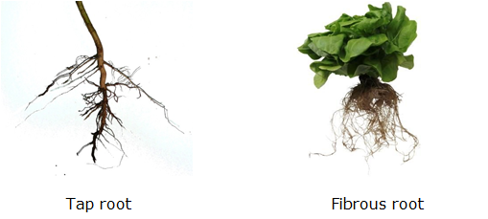

Q11. How do plants exchange gases with the environment?
Ans. Exchange of gases takes place in the plants mainly through the tiny pores on the surface of their leaves called stomata.

Q12. Do the flowers with joined sepals have petals that are separate or are they joined together?
Ans. If the sepals of flowers are joined together, then its petals may or may not be joined together.

Q13. Do the flowers with joined petals have stamen joined to the petal?
Ans. If the petals of flowers are joined together, then its stamen may or may not be joined to the petal.

Q14. What type of roots the plants with parallel venation in the leaves likely to have?
Ans. Plants with parallel venation in the leaves likely to have fibrous roots. For example: grass, wheat, maize, etc. have fibrous roots with parallel venation.

Q15. How stem is like a two way street?
Ans. Stem is like a two way street as it conducts water and minerals from the roots to the leaves and transport food prepared by the leaves to the other part of the plant.

Q16. Do all the leaves have petioles?
Ans. No, all the leaves do not have petioles. Some leaves have a petiole, which attaches the leaf to the stem and some leaves that do not have petioles are directly attached to the plant stem.

Chapter 7 - Getting to Know Plants - 2

Q17. What are the functions of the petals and sepals in flowers?
Ans. Function of Petals – Bright color of petals helps in pollination by attracting insects such as butterflies and bees to the flower.
Function of Sepals – It protects the developing flower from any harm.

Q18. Why are leaves of few plants modified into tendrils? Give examples.
Ans. In weak- stemmed plants, leaf or a part of leaf gets modified into green threadlike structures called tendrils which help in climbing around the support. Example: pea plant

Q19. Why is it difficult to separate the sprouted young plants from the cotton wool?
Ans. Roots fix the plant firmly in the soil. In case of sprouted young plants, the roots grown fix the seeds in cotton wool and thus make it difficult to separate these from cotton wool.

Q20. What are trees? Give two examples of trees.
Ans. Some plants are very tall and have hard and thick brown stem. The stems have branches in the upper part, much above the ground. Such plants are called trees.
Examples: Mango tree, Neem tree, Peepal tree etc.

Q21. Explain through an activity that stems conduct water.
Ans. Pour some water in a glass. Add a few drops of red ink to the water. Cut the base of the stem of the herb. Now put it in the glass. We will observe that some parts of the herb appear red. This shows that stem conduct water.

Q22. What are weeds? Why farmers remove them from their field?
Ans. Weeds are unwanted plants that grow along with the crops and compete with normal healthy plants for water, light, soil nutrients and space.
Farmers remove them from their field because they compete with the crop growing in the field.

Q23. What are the two types of leaf venation present in leaves? Write one example of each type of venation.
Ans. The two types of leaf venation present in leaves are reticulate venation and parallel venation.
Example of Reticulate venation – coriander, rose, tulsi, maple, and oak
Example of Parallel venation - aloe vera, coconut, banana, lily, maize, grass, and wheat

Q24. Differentiate between creepers and climbers.
Ans.
creepers | climbers
1. Plants with weak stems that cannot stand upright and spread on the ground are called creepers. | 1. Plants with weak stems that take support on neighboring structures and climb up are called climbers.
2. Examples: watermelon, pumpkin, etc. | 2. Examples: pea plant, money plant, etc.

Q25. What are the two types of root systems? Explain each of them with examples.
Ans. The two types of root systems are tap root system and fibrous root system.
Tap root system: There is one main root called tap root from which smaller roots sprout laterally called lateral roots. Examples: Beetroot, Carrot, Sugar beet, Dandelion etc.
Fibrous root system: In this root system, roots are thin and of more or less equal length growing from the stem. Examples: wheat, maize, rice etc.

Q26. Differentiate between herbs and shrubs.
Ans.
Herb | Shrub
1. Plants with green and tender stems are called herbs. | 1. Plants with many stem branching out near the base are called shrubs.
2. Herbs are non-bushy plants. | 2. Shrubs are bushy plants.
3. Herbs are small plants but smaller than shrubs. | 3. Shrubs are small plants but taller than herbs.
4. Examples: Basil, Coriander etc. | 4. Examples: Rose, Lemon plant etc.

Q27. Name the different parts of the plant. Mention main functions of each part.
Ans. Parts of plants and their function
1. Stem – The main function of the stem is to support the shoot of the plant. It conducts water and minerals to the leaves and transport food prepared by the leaves to the other part of the plant.
2. Roots – It provide support to the plant in the soil. It absorbs water and other nutrients from the soil and transports these things to the stem.
3. Leaves – It prepares food for plants by the process of photosynthesis. It helps in interchange of gases between the atmosphere and the plant and evaporation of water.
4. Flowers – The primary purpose of a flower is reproduction. It produces seed which produce new plants.

Q28. Explain the following terms.

a. Transpiration
Transpiration is a process through which excess water comes out of leaves into the atmosphere in the form of vapor.

b. Photosynthesis
Photosynthesis is the process through which green plants prepare their food in the presence of sunlight, water, carbon dioxide and green pigment called chlorophyll.

c. Petiole
Petiole is a stalk by which leaf blade is attached to the stem.

d. Lamina
The broad, green part of the leaf is called lamina.

e. Midrib
The thick central vein present in the middle of the leaf is called midrib.

f. Leaf Venation
The pattern made by fine lines of veins in a leaf is called the leaf venation.

g. Bud
Bud is a compact knob-like structure that grows on a plant which later develops into a leaf, flower, or shoot.
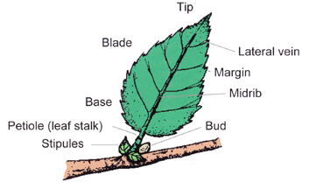

Q29. Define the following part of a flower.

a. Sepals
Sepals are green leaf like structures forming the outermost part of a flower that surround the petals.

b. Petals
Petals are brightly colored parts of a flower that surround the reproductive organs.

c. Stamens
Stamens are the small, delicate stalks which grow at the flower’s center and produce pollen. It consists of an anther and a filament.

d. Filament
Filament is a fine thread like structure that supports the anther of a flower.

e. Anther
Anther is a part of a stamen that contains the pollens and occurs at the tip of filament.

f. Pistil
Pistil is the part of a flower that comprises of stigma, style and ovary.

g. Ovary
Ovary is the lowermost and swollen part of the pistil.

h. Style
It is a long and slender stalk like structure that connects the stigma and the ovary.

i. Stigma
The stigma is the head of the pistil and is a sticky platform which receives pollen.
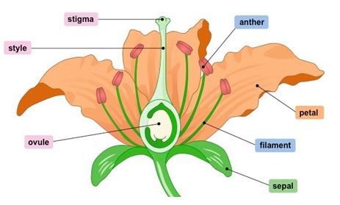

Q30. Explain an activity to show that plant transpires.
Ans. Take a healthy plant. Enclose a leafy branch of the plant in a polythene bag and tie up its mouth. Tie up another branch without leaf with a polythene bag. Keep the plant in the sun. After a few hours, we observe tiny droplets of water on the inner surface of polythene bag with leaves and no water in the polythene bag which encloses the empty branch. This shows that plant transpire.

Q31. Write an activity to test the presence of starch in a leaf.
Ans. Take a leaf in a test tube and pour spirit to completely cover the leaf. Now place the test tube in a beaker half filled with water. Heat the beaker till all the green colour from the leaf comes out into the spirit in the test tube. Take out the leaf carefully and wash it in water. Put it on a plate and pour some iodine solution over it. We will see that colour changes to blue black. This shows the presence of starch in a leaf.

Q32. How do we know that the leaf has prepared the starch and not received it from another part of the plant?
Ans. To test this, place a potted plant with green leaves, in a dark room for a day or two. Now, cover a portion of a leaf of the plant completely with black paper and leave the plant in the sun for a day. Remove the leaf covered in black paper and pour some iodine solution over it. Change of color to blue black shows presence of starch.

