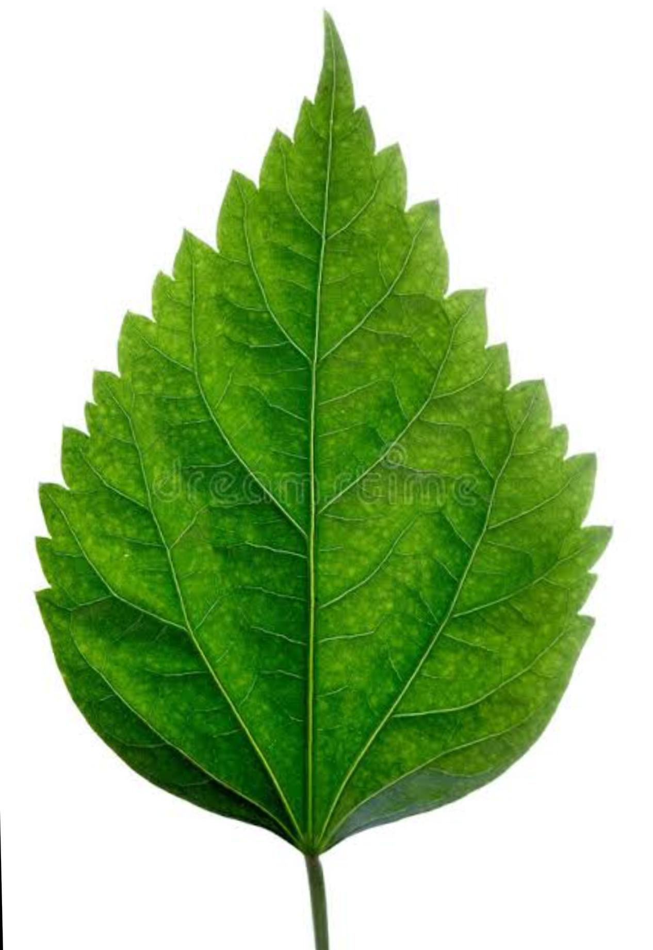**CLASS IV EVS WORKSHEET**

1. **Identify the picture and label it.**
2. **Why is this green in colour?**
3. **Write two functions of this part of a plant.**

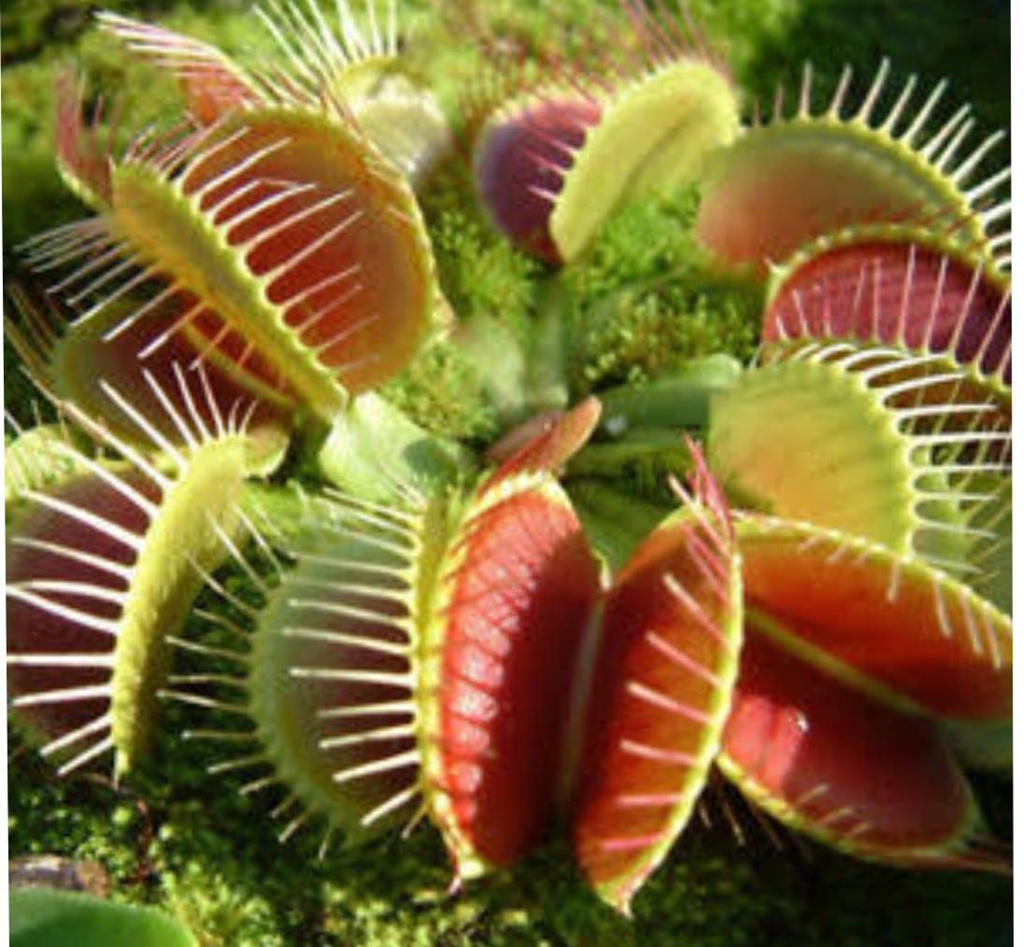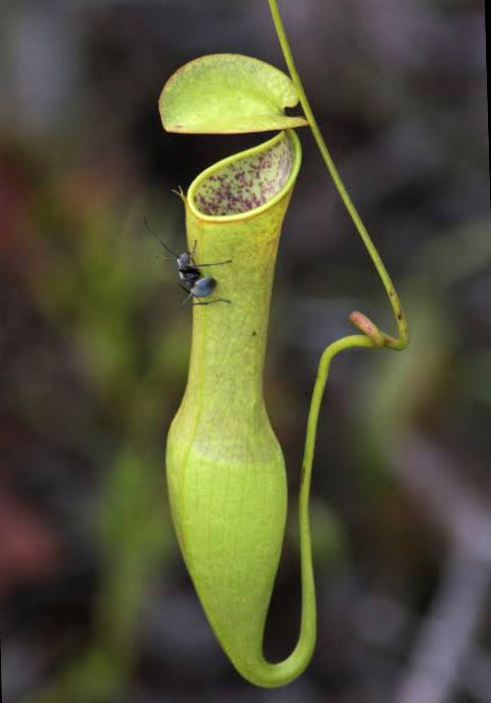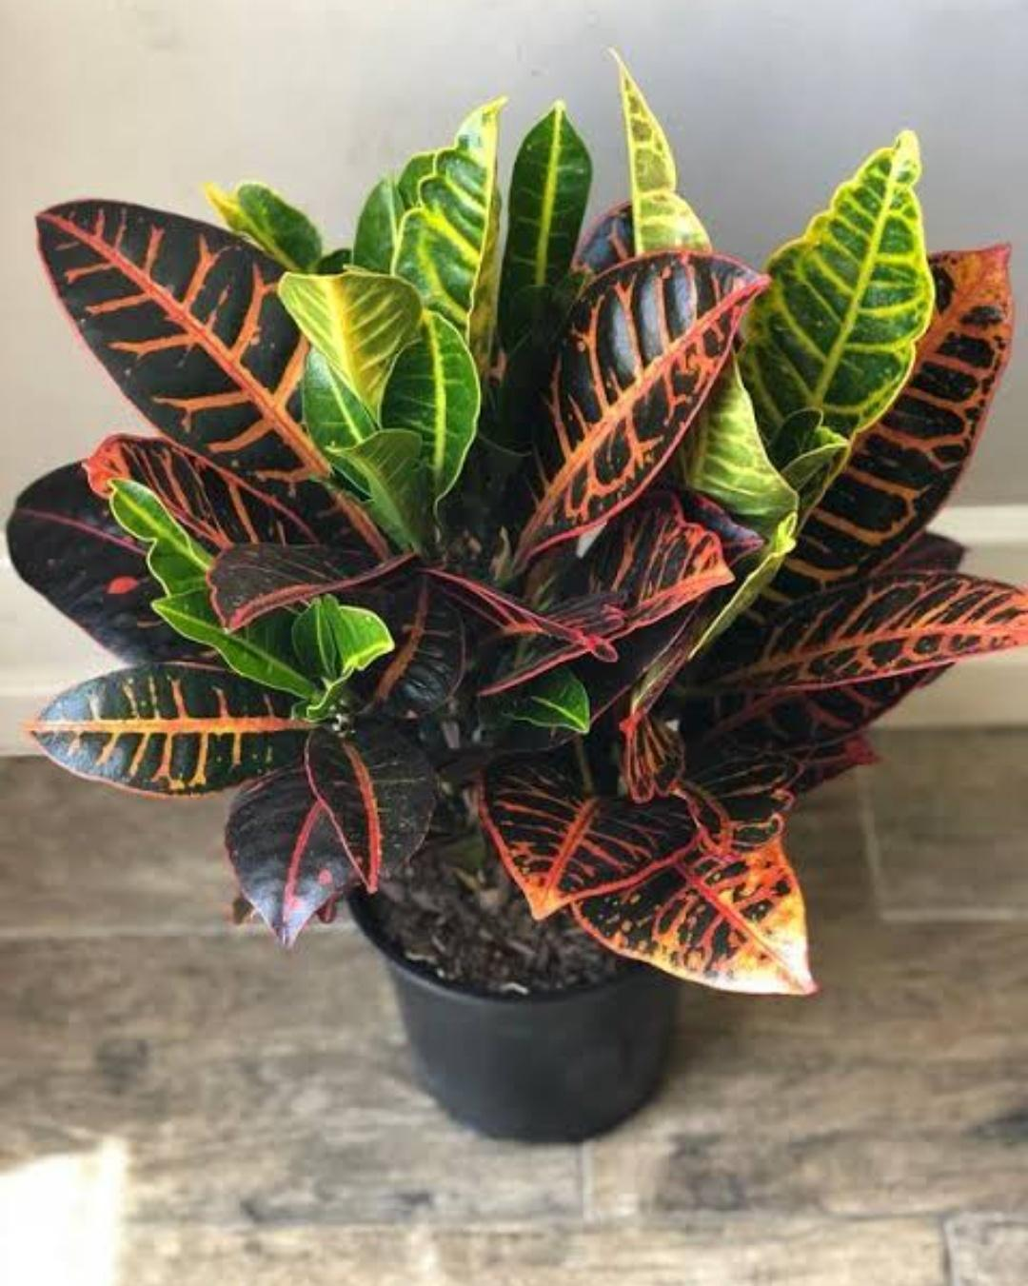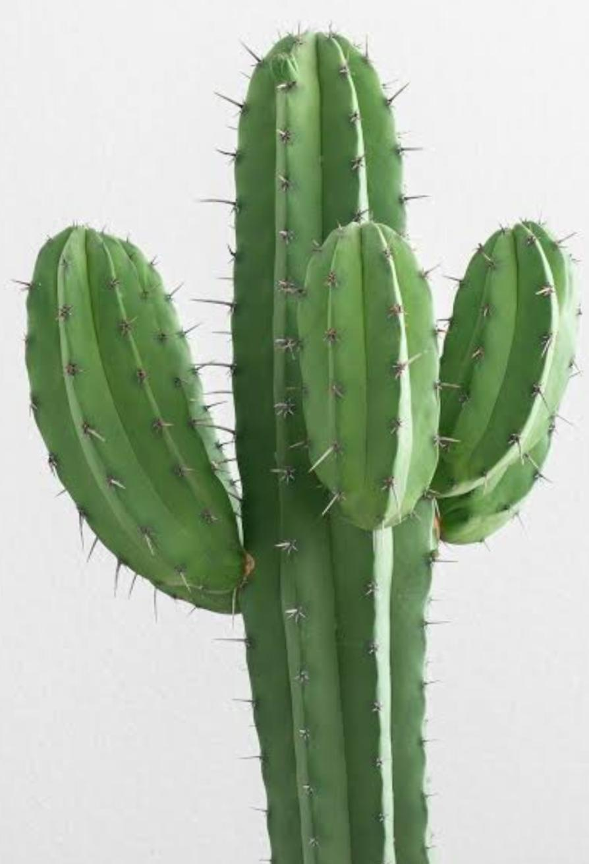**Identify the following unusual plants**