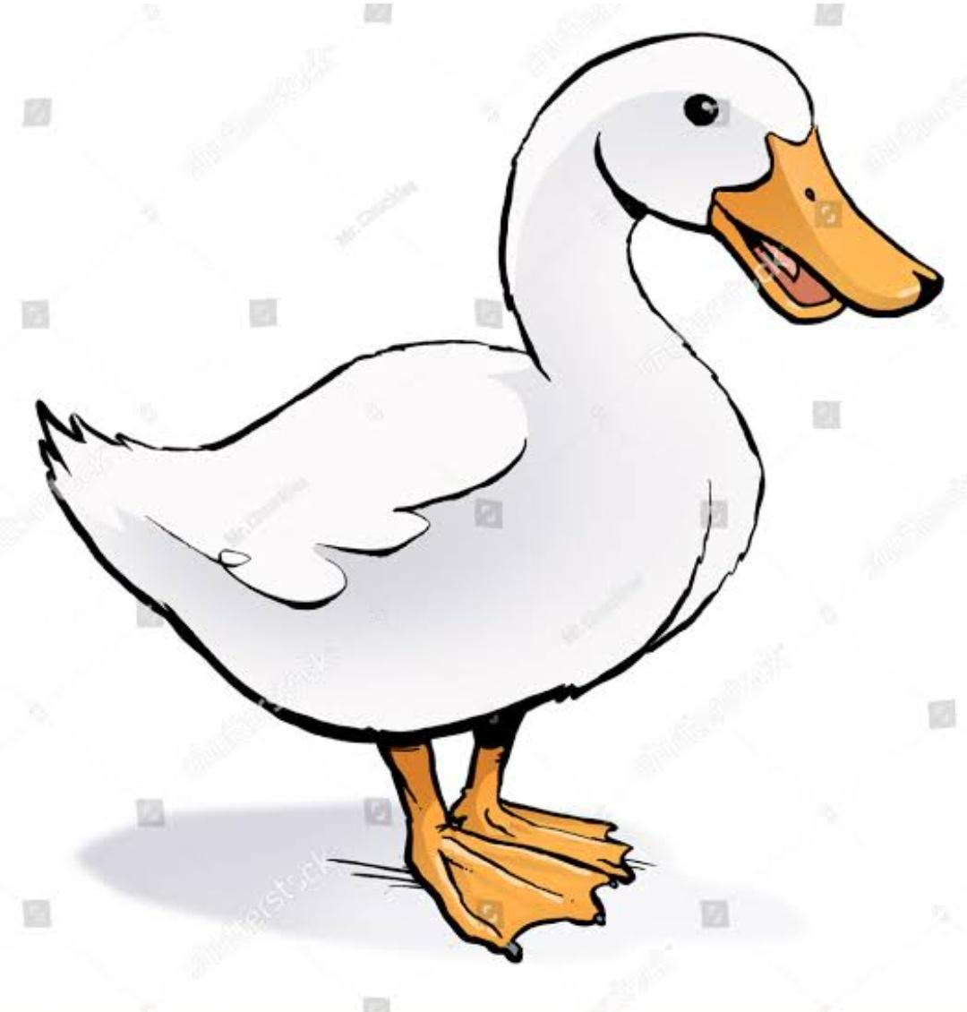
CLASS III EVS WORKSHEET
Fill in the blanks :-
- _________and _________ have a broad and flat beak with tiny holes.
- When they take muddy water with insects in their beak, the muddy water flows out from the _______ ______ .
- They have _____ feet to swim in water.
- They have ____toes at front are joined by skin.
- This type of feet help them ______and ________ water while swimming.
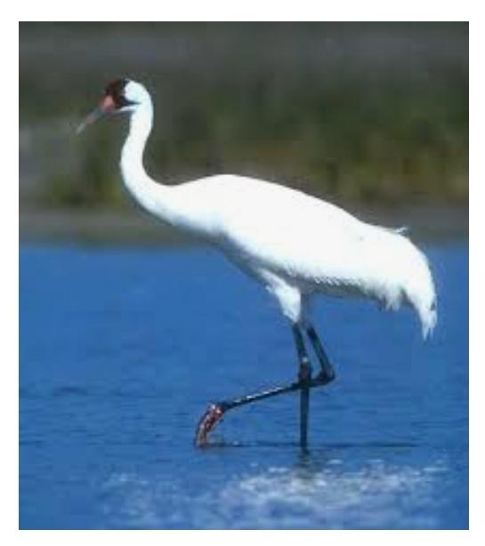
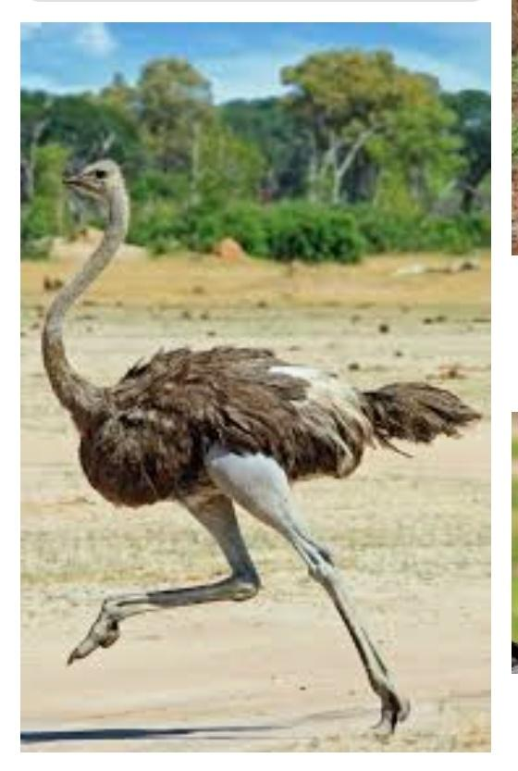
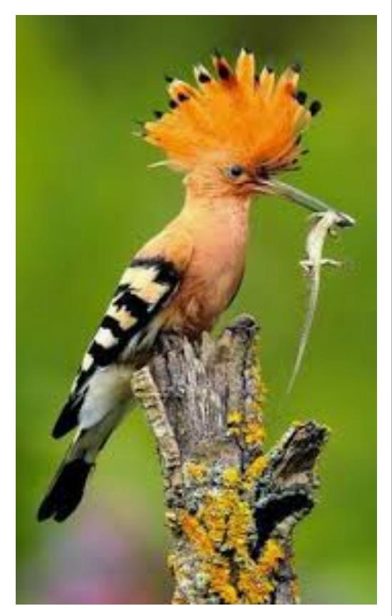
Name the following birds.
