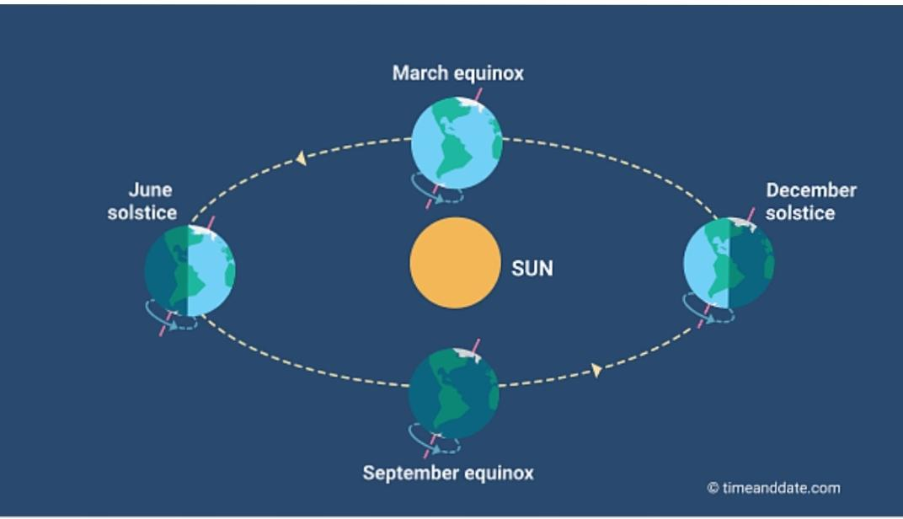
CLASS VI GEOGRAPHY WORKSHEET
Match the following :-
( with the help of the above image)
Column A Column B
1.Summer Solstice a. 365 days
2.Winter Solstice b. 23 September
3.Autumnal Equinox c. 22 December
4.Spring Equinox d. 366 days
5.Revolution of the Earth e. 21 June
6.A leap year f. 21 March

