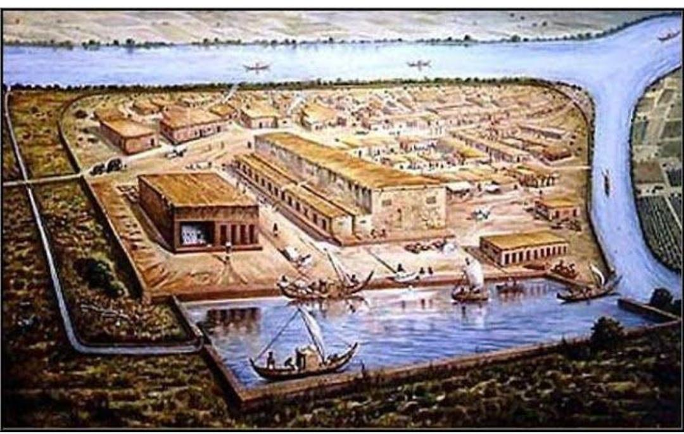
CLASS VI HISTORY WORKSHEET
Identify the above image.
Fill in the blanks :-
- This city is a ______ site.
- It is situated between _____ and ____ river.
- It is in ____ ,state in India.
- It is close to the Gulf of ______
- It was a ______ town.
- The most important brick structure in this place is ________ .
- It was an important _______ centre.
- A large __________ has found in the citadel area.

